Haley Barrett, Kody Koch, Juan Patino, Josh Reid, Matthew Roberts, Frank Silva

FAMU-FSU College of Engineering  2525 Pottsdamer St. Tallahassee, FL. 32310

Team 307: Emergency Management Drone

4/26/2019

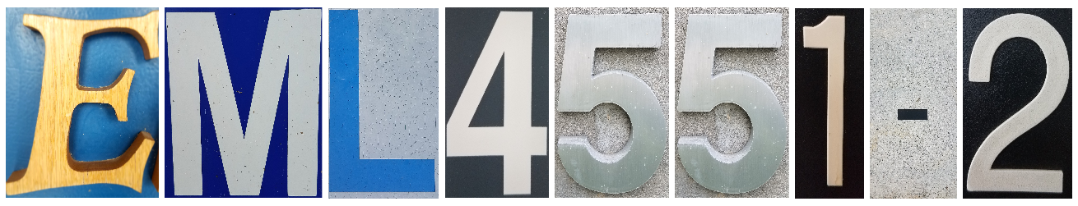

# Abstract

Drones are very important to utilize in dangerous situations or inaccessible terrain. Our sponsor, the Florida State Emergency Management and Homeland Security (EMHS), contacted us to create a drone that uses a computer to find targets in emergency situations. This project is a continuation of a previous senior design project. The past design did not meet the customer’s needs for flight time or flight range. The customer wants longer flight time and range to have a more effective search and rescue option. To increase the flight time, we are using batteries with more energy and a more effective power system. We are also using a better communication system in order to get the desired range. We are designing the drone to be more like an airplane instead of a helicopter so that the drone can travel through the air more efficiently. Due to these factors, we find that the drone can now cover a larger area than the last design. The original design of the drone was built to have a flight time of around 10 minutes along with a low range. With the fixed wing design and new communication systems, the drone will achieve a flight time of about 70 minutes and a range of about 10 km.

# Disclaimer

In order to operate this device safely, it is important that the battery is not operated below a 20% capacity, and the cables are not operated on while the battery is connected. To mitigate the possibility of frying the communications board, do not point the Yagi antenna towards the drone within 5 feet from each other while communications are running. Also, do not operate or point the Yagi antenna towards any person for an extended period of time, and avoid pointing it towards transmission lines.

# Acknowledgement

Team 307 would like to give a special thanks to our sponsor, David Merrick, for providing the opportunity for us to be a part of this project as well as being an active supporter of the project’s progression. We would also like to express our gratitude to our advisor, Rodney Roberts, for providing constant advice and support. Team 307 would like to also thank Dr. Harvey, who provided advice and knowledge about the communication systems. Lastly, we would like to thank our design instructor, Jerris Hooker, for always providing technical advice as well as aiding us through each step of the project.

Table of Contents

Abstract ii

Disclaimer iii

Acknowledgement iv

List of Tables ix

List of Figure x

Chapter One: EML 4551C 11

1.1 Project Scope 11

1.2 Customer Needs 11

1.2.1 Interview Questions 11

1.2.2 specifications determined from the sponsor interview. 12

1.3 Functional Decomposition 12

1.4 Target Summary 14

1.5 Concept Generation 16

Concept 1. 18

Concept 2. 18

Concept 3. 18

Concept 4. 18

Concept 5. 19

Concept 6. 19

Concept 7. 19

Concept 8. 19

Concept 9. 20

Concept 10. 20

Concept 11. 20

Concept 12. 21

Concept 13. 21

Concept 14. 21

Concept 15. 21

Concept 16. 22

Exclusions 22

1.6 Concept Selection 23

1.7 Spring Project Plan 35

Chapter Two: EML 4552C 38

2.1 Restated Project Scope 38

2.1.1 Key Goals 38

2.1.2 Markets 38

2.1.3 Assumptions 39

2.1.4 Stakeholders 39

2.2 Results 39

2.2.1 Experimental Flight Results 39

2.2.2 Power Management Results 39

2.2.3 Communication System Results 40

2.2.4 Image Processing Results 41

2.3 Discussion 42

2.4 Conclusion 43

2.5 Future Work 43

Appendix A: Code of Conduct 45

Appendix B: Functional Decomposition 49

Appendix C: Target Catalog 50

Appendix D: House of Quality 51

Appendix E: Calculations 52

Aerodynamic Calculations 52

The following calculations were used to calculate specific aerodynamic properties of the wings. The constants used in each equation are represented in Table 15. 52

Communication Equations 53

Appendix F: Engineering Drawings 53

Appendix G: Aerodynamic Calculations Code 57

Lift and Drag 1 57

Lift and Drag 2 58

Appendix H: Neural Network and Communications Code 60

Neural network 60

Tx Communications 65

Rx Communications 67

References 71

# List of Tables

Table 1 Concept Generation Table 7

Table 2 Concept Selection Criteria 14

Table 3 Vehicle Type Pugh Chart 14

Table 4 Motor Configuration Pugh Chart 16

Table 5 Airfoil Shape Pugh Chart 1 18

Table 6 Airfoil Shape Pugh Chart 2 18

Table 7 Material Selection Pugh Chart 19

Table 8 Processor Pugh Chart 1 20

Table 9 Processor Pugh Chart 2 21

Table 10 Camera Selection Pugh Chart 22

Table 11 Power Management Pugh Chart 23

Table 12 Communications Pugh Chart 24

Table 13 Final Selection Table 25

Table 14 Summary of Tasks 28

Table 15 Parameters for Aerodynamic Equations 43

Table 16 Parameters of Communication Equations 44

# List of Figure

Figure 1. Functional decomposition diagram 3

Figure 2. Configurations of motors for a multirotor drone [1] 7

Figure 3 Skywalker black X8 flying wing drone [2] 14

Figure 4 NACA 0012 airfoil [3] 16

Figure 5 NACA 1408 airfoil [3] 16

Figure 6 20-32C airfoil [3] 16

Figure 7 NACA 63(2)-615 airfoil [3] 17

Figure 8 Gantt Chart Spring 2019 26

Figure 9 Tiny Yolov3 Training Results 32

Figure 10 Assembled View of the Electronics Box 44

Figure 11 Dimensions of Electronics Box 45

Figure 12 Part Number Labels 46

Figure 13 Dimensions of the Airframe 46

# Chapter One: EML 4551C

## Project Scope

The current iteration of the client’s drone, while functional, is not practically useful and needs to be improved to be effective. In particular, the range, flight time, and camera stabilization are of vital importance. Moreover, the client has also requested a number of improvements to the user interface, including autonomous flight. The design must be made with reliability and longevity as primary characteristics. If successful, this drone design could be used not only in emergency situations, but also for general wide-area searching.

The primary users of this design will be the Department of Emergency Management and Homeland Security (EMHS), but could also be used by various organizations including the FBI for kidnapping cases, conservation groups for counting animals, and penitentiaries to aid in the capture of prisoner escapes. The final product of this design will also be able to aid in environmental disaster surveys and reliefs. The city of Tallahassee could be a tentative stakeholder for this project. Several departments such as the police and the fire department would benefit from having an Emergency Management Drone at hand for situational purposes.

## Customer Needs

After speaking with the customer, it became relevant that the current version of the drone design is not up to par for the needed performance. As requested by the customer, the main focus of adjustments to the drone will be flight time, flight range, and camera stabilization. The budget has been set at 1,500$ but is flexible.

### 1.2.1 Interview Questions

1. How many times was the current drone design flown?
   1. One time
2. What are the complications with the current drone design?
   1. Camera vibrations
   2. Range is abysmal
   3. Flight time is too short, around 10 minutes
   4. Poor user interface
   5. Flight is not autonomous
3. Is reliability or speed a higher priority?
   1. Range and efficiency are of much higher priority than speed
   2. Possibility of switching from video footage to still images since speed is not a concern
4. How often are the photos taken?
   1. Live video footage is currently used
5. Is there a set budget for this project?
   1. The budget is sitting around a few thousand dollars

### 1.2.2 specifications determined from the sponsor interview.

* Video footage is not a necessity; as long as the user is able to access what has been detected by the image processing unit and receive coordinates, they can then determine whether ground resources are needed.
* The flight time can be improved in a variety of ways.
  + Heavy optimization of both the power consumption and the multi-rotor’s mass could increase the flight time.
    - If the mass is reduced enough, the drone could be downgraded from 6 rotors to 4 rotors which would reduce both power consumption and mass.
  + The overall design could be changed to a fixed wing design which is inherently more power efficient.
    - A fixed wing design can introduce problems related to launching and recovery of the drone.
  + The flight range can be improved by using more powerful transmitters, or by introducing a lower frequency band.
    - Stronger transmitters will increase power consumption, but using a lower frequency band reduces the data transfer rate.

## Functional Decomposition

The main function of the emergency management drone is to conduct successful and efficient search and rescue missions. There are several sub functions that make this possible. The drone design was split up into six sub functions that are analyzed in Figure 1.

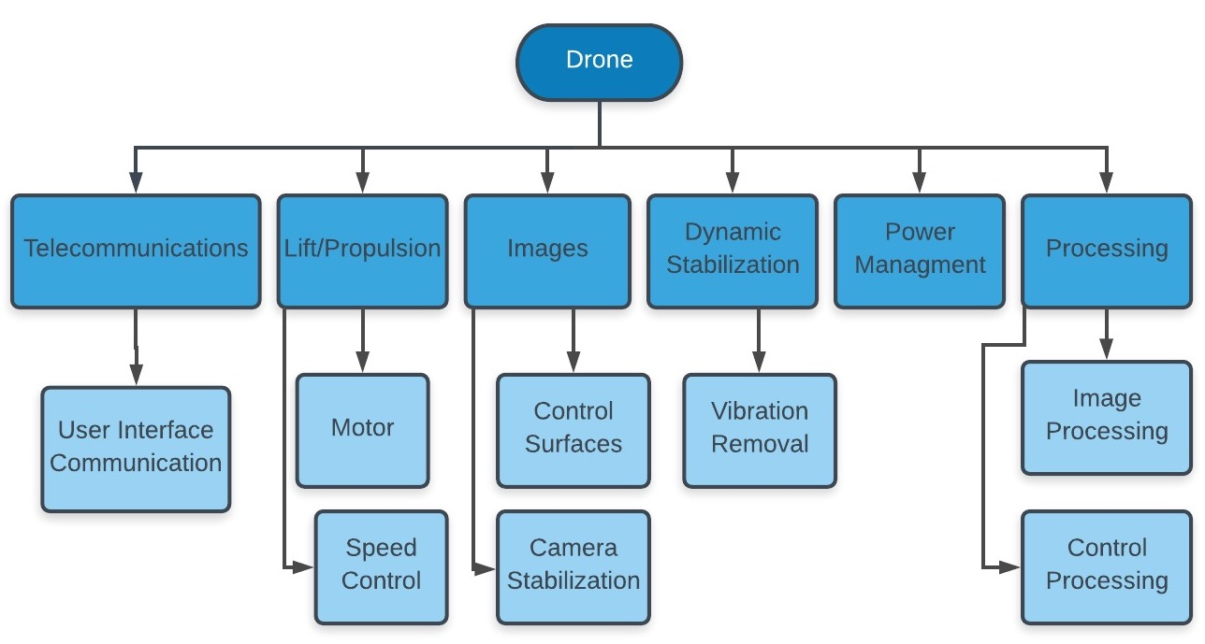

Figure 1. Functional decomposition diagram

Telecommunications is an integral part of the drone; the drone must be able to communicate with a source on the ground to control and receive the images transmitted from the drone. Lift and propulsion are other vital aspects of the drone design and will allow the device to overcome drag forces in order to be remain airborne after take-off. Subcategories of lift and propulsion include power from a motor and speed control. A motor is needed to convert electrical energy to mechanical in order to provide the drone with power, whereas speed control will regulate the movement of the device once in flight. Along with lift and propulsion, power management is needed to route power from batteries to the computer and motor(s) and also regulate the power efficiently.

Stabilizing the camera is needed to provide the user with quality images for object detection, and control surfaces prove to be a very important function in the stabilization of the drone as a whole. Dynamic stabilization is essential for the drone to stay controllable at all times, even in unidealistic conditions. Eliminating vibrations will help with both the image processing and the flight controls of the drone.  Lastly, the processing will be done by the computer in the drone which will process the images and control the drone as it moves.

## Target Summary

Target 1 quantifies how far can the drone be reliably operated from the pilot. An increased range from the previous iteration of the drone was specified by the customer as an essential need for this project. The customer argued that being able to fly the drone a longer distance away from the drone operator was essential to the search and rescue efforts that his team conducted. The marginal value for the range of the drone was chosen to be 1 kilometer, while an ideal value would be 2 kilometers. These values were chosen so that the customer and his team can take advantage of the enhanced visibility that a bird’s eye view provides. The flight range will be improved by overhauling the communications system by removing the 2.4GHz communication and using a more reliable standard. The flight range will be tested in a large open field, provided that there are no bystanders and line of sight will always be maintained on the drone. The weight (5 being most important) of target 1 has been rated at 5 because the customer noted that this was an essential upgrade that they required.

Target 2 quantifies the time the drone is able to remain airborne. Increasing the flight time was specified by the customer as a high valued need, and vital function to the drone’s practicality. The customer has clarified that ideal flight time would be 20 minutes or greater. In the past, the drone has had a flight time of an average of 10 minutes. The plan to increase the flight time is to redesign the structure of the previously designed 6 rotor drone to cut down on power consumption and in return, increase flight time. The new structure of the drone would be the one of a fixed wing UAV, the use of this design would decrease the power consumption which would greatly increase the flight time. The importance of target 2 has been rated at a 5 because it was directly communicated from the customer as a top priority.

Target 3 quantifies how clear the images are once they’ve been transmitted from the drone to the ground. There are many concerns with taking photos/videos on a moving platform, however the main concern is the vibration. If the platform is vibrating too much, then the images taken from the camera will not be clear enough for the image processing program to reliably operate. Therefore, camera stabilization is essential. The marginal value for camera stabilization was chosen to be 80% of the vibrations to be reduced, while the ideal value was chosen to be 100% of the vibrations to be reduced. Camera stabilization will be tested by flying the drone erratically and taking video. The footage will be reviewed to determine the clarity of the images captured. We plan to improve camera stabilization by using rubber mounts where the gimbal mounts to the drone. Using a more reliable gimbal will also help reduce the vibrations produced on the drone. The weight of Target 3 has been rated at 4 because camera stabilization is essential to the success of the image processing program, but it is not essential to the drone’s operation.

Target 4 correlates cruise speed to the need of longer flight time to ensure that the drone last as long as its required. The marginal value was chosen to be 30 km/h which is a little bit faster than what it actually needs to be. An optimal cruise speed has been chosen at 25 km/h which will be the perfect speed for the drone to capture a point of importance for the search and rescue team. This target will be verified in a large open field using measurements capacities available in FlytOS to make sure that the cruise speed needed is archived. The importance of this target is 1 because speed is not a priority as long as the drone is able to successfully detect objects in an efficient matter.

Target 5 quantifies the necessary power for the drone to work properly and last as long as its required. A reduction in the power consumption of the drone will be essential to increase the flight time as required by the sponsor. Being able to regulate the power consumption to an optimal level will increase the control on the amount of thrust produced by the motor. The marginal value for the power consumption was chosen to be 150W. This amount of power gives the drone the ability of working for at least 30 minutes at the desired capacity. The ideal value for the power consumption would be 125W, with this capacity we think that the drone would be able to fulfill all of the requirements while also using less power compared to the previous iteration of the drone. This target will be verified by running the drone for 30 minutes and testing the drone afterwards to assess the power consumption. This target is rated at 5 because lowering the power consumption of the drone is essential for its correct functionality as described by the needs of this project.

Target 6 identifies the options for autonomous flight. Having a predetermined autonomous flight path ensures a wide section is covered without there being a need for a person to pilot the drone. There is an open source code for autonomous flight that will be used to implement this feature into the drone. The marginal value chosen for this target was 50% autonomous, while the ideal value for autonomous flight is 80%. The weight of this target has been rated at 4 because autonomous flight is important in making sure the best search path is covered but is not mandatory in making the drone achieve its goal.

Target 7 compares the flight time of the vehicle to the total vehicle mass. By reducing the mass of the entire drone, the drone will be able to fly for a longer time as the heavier the vehicle is, the more power will be needed to counteract its weight. The marginal value for the mass of the drone is 2.5 kg, with the ideal value being less than 2 kg. It will be easy to determine the mass of the drone, through the use of some sort of scale. This metric is rated as a 3 in importance, as decreasing the drone’s mass will be helpful in reducing the power demands but is not essential to the drone’s operation.

Target 8 compares the flight time of the vehicle to the payload mass of the vehicle. Reducing the mass of the payload will in turn reduce the amount of power needed to fly using the same logic as in Target 7. The marginal value for the payload mass is 1.5 kg, with 1 kg being the ideal payload mass. As with Target 7, the mass of the payload can be easily measured with the same previously mentioned scale. This metric is also rated as a 3 for the same reasons as with Target 7.

## Concept Generation

The following section includes a table, represented as Table 1, of all of the components of the design with corresponding options and an explanation for the dominant concepts generated from the table. The design was split up into two main vehicles, a multirotor drone and a fixed wing vehicle. A total of 16 feasible concepts are discussed below.

Table   
Concept Generation Table

|  |  |  |  |  |  |  |  |
| --- | --- | --- | --- | --- | --- | --- | --- |
| **Components** | Options | | | | | | |
| **Vehicle Type** | Multi-Rotor | Fixed Wing |  |  |  |  |  |
| **# of Motors** | 1 | 2 | 3 | 4 | 6 | 8 |  |
| **Motor Configuration** | Quad Rotor  “+” | Quad Rotor “X” | Y-6  Rotor | X-8 | Nose | Wings | Nose and Wings |
| **Frame Material** | Carbon Fiber | Foam | PLA Filament | Epoxy Fiberglass | Aluminum | PVC |  |
| **# of Battery Packs** | 1 | 2 |  |  |  |  |  |
| **Type of battery** | 1s | 2s | 3s | 4s | 5s | 6s |  |
| **Power Management** | Linear Voltage Regulator | Buck Boost Converter | Buck Converter | Fly Buck Boost |  |  |  |
| **Camera** | Thermographic | Gopro | Webcam | FPV |  |  |  |
| **Processor** | NVIDIA TX1 | NVIDIA TK1 | Odroid XU4 | Raspberry Pi 1 | Raspberry Pi 2 | Raspberry Pi 3 |  |
| **Communications** | Directional Wifi | 4g | 3g | Directional Antennas |  |  |  |
| **Airfoil** | NACA 0012 | NACA 1408 | 20-32C Airfoil | NACA 63(2)-615 |  |  |  |
| **Fuselage** | Blunt Body | Bluff Body | Narrow Body | Flying Wing |  |  |  |
| **Landing** | Parachute | Belly Land | Landing Gear |  |  |  |  |

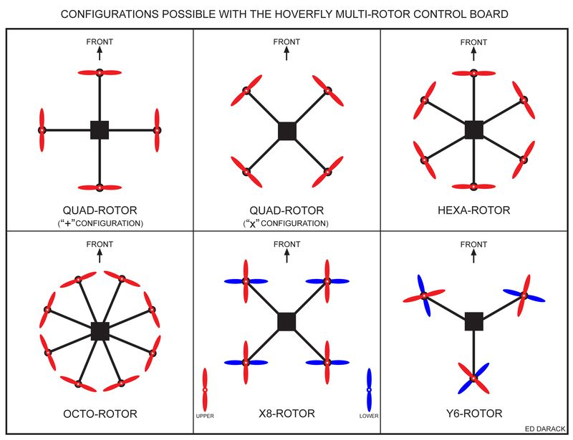

Figure 2. Configurations of motors for a multirotor drone [1]

### Concept 1.

The idea behind this design is to minimize the budget while keeping a standard frame configuration for a multirotor drone. This design would be a quad rotor with a “X” configuration, shown in Figure 2. By using PLA filament for the frame material, the price would decrease while still providing the drone with the needed frame support. Although PLA filament is brittle, a multirotor drone has the ability to hover land which will minimize impact force to the drone. This design would have one standard three cell battery to minimize weight and use a buck boost converter to conserve power. A Raspberry Pi 3 processor was chosen to keep the budget down and lower power consumption from the previously used NVIDIA TX1 processor.

### Concept 2.

This design was made to keep the features from the previous drone, ‘Saurus’. The goal of this design is to optimize the weight such that only four motors will be needed, and redesigning the power management for efficiency. Since this processor is very powerful, the autonomy of the drone could be improved significantly by adding features such as investigation of points of interest (such as reducing altitude to get a better image). Since a new frame would be required, carbon fiber was chosen due to its durability which will remain intact in various weather conditions.

### Concept 3.

This design was made with maximum multirotor range in mind. By optimizing the weight of the drone to only require four motors and by using a less power-hungry processor as well as better power management, the flight time of the drone would be significantly increased. In conjunction with using 4G communication, the drone would have significantly higher effective range.

### Concept 4.

The main idea behind this design was to take advantage of the “Y” configuration, shown in Figure 2, to optimize power consumption and range of the drone. The frame material of this drone would be plastic to lower the weight of the drone accordingly. The communication system would be directional antennas which will give the drone longer range as desired by the customer. This design will use a three-cell battery in combination with a buck boost converter for power management. As for the camera, a Thermographic camera would be the main choice in combination with an NVIDIA TX1 for processing.

### Concept 5.

This design was made with optimization in mind. It uses four motors in a quad-rotor “+” configuration, shown in Figure 2. The frame material for this design would be carbon fiber which was the one used in the “Saurus” drone. Similar to concept four, the communication system would use directional antennas which offer a much larger range compared to Wi-Fi or 4G. For the power management, a three-cell battery will be used in combination with a buck boost converter. The camera would be a webcam which was used in the previous group drone design, and the main microprocessor choice for this design would be the NVIDIA TX1.

### Concept 6.

This design was made to optimize the drone’s power usage. Three motors will be utilized in a “Y-6” configuration shown in Figure 2. The frame material will be foam to keep the weight of the drone light and the structure easy to repair. For power management, the drone will use a three-cell battery as well as a buck boost converter. A GoPro will be implemented to minimize power consumption, while still being able to take clear and usable pictures. The communication system will use a 4G network. This will allow the drone to fly at at decent range without consuming a substantial amount of power. Finally, the processor chosen was the Raspberry Pi 3. This processor is light and not as power hungry as others, making it ideal for this design.

### Concept 7.

In this design, four motors will be used in a “+” configuration. The use of an FPV camera will be implemented to provide live feed to the viewers. This will result in the system consuming more power. Two 3 cell batteries will be implemented to accommodate for this additional use of power. The drone will use foam for its frame material in order to keep it light. This will also help the power consumption aspect of this design. Directional antennas will be used for the communication system of the drone. This will increase the range capability of the drone. Finally, the processor chosen for this design is the NVIDIA TX1. This processor will be able to handle the power required for the FPV camera.

### Concept 8.

Concept 8 is a hexacopter with dual battery packs. The camera on this design would be FPV camera which would broadcast live feed to a source on the ground. Live feed imagery would require more power and therefore two battery packs would be used in this design. Using six motors opposed to four would allow the drone to carry more weight, which would be the extra battery pack in this case. Carbon fiber was chosen for this design to allow more weight to be taken up by the batteries which will enhance the flight time and range of the vehicle.

### Concept 9.

This design was made with ease of launch and landing in mind. A fixed wing vehicle design was chosen using a NACA 1408 airfoil to provide very high lift and to have a very low landing speed. Using EPA foam will make the drone durable and light, and will be very easy to repair for minor scuffs and belly damage. The fly buck boost converter was chosen to increase power management so that only one battery needs to be used. The camera was chosen to be light, have very high frames per second, and to have a high field of view such that individual images can be stabilized to be very clear for the image processing. The 4G communication should be sufficient for ground communication since a maximum of one picture per second is expected to be sent. The processor was chosen to have maximum processor utilization for power spent for stabilization, image processing, and flight control.

### Concept 10.

This design was made with speed in mind. The 20-32C Airfoil was chosen to maximize lift during the initial climb and provide a good lift versus drag characteristic. This drone would have a flying wing fuselage with aluminum as the frame material so that it can survive the high drag. Three motors would be used to maximize the flight speed and the aerodynamic control while at high speeds.  A fly buck boost converter was chosen to maximize flight time by using power efficiently. The image processing system would be designed to be a basic Raspberry Pi 3, and the communications scheme (3G) would be designed to send very few images in order to minimize power consumption.

### Concept 11.

This design was also made with ease of launch and landing in mind. Again, the airfoil was chosen as a 20-32C airfoil to have very high lift and to have a very low stall speed, making it very easy to fly and land. Using a foam body will make the drone be very durable in the event of a crash. Similar to concept 10, the power management system was chosen to be very efficient so that only one three cell battery would need to be used. The camera used for this concept will be a small FPV camera because a lot of weight will be taken by the NVIDIA TX1 processor that will be used for this design. This design also incorporates the use of a parachute system which the operator can use to stall the aircraft, and then deploy the parachute so that there the required landing distance is reduced significantly. Essentially, the aircraft is oriented towards safe landings, and very pilot friendly.  This concept uses directional antennas as its form of communication.

### Concept 12.

This design concept is very similar to Concept 11 in most aspects besides the camera system. This concept will have a FPV camera to opposed to a webcam. The increase in weight from the upgraded camera means that the Raspberry Pi 3 microcontroller will be used instead of the NVIDIA TX1 to reduce weight. This concept also differs from Concept 11 in its form of communication. This concept will be using 4G for its main mode of communication.

### Concept 13.

This design introduces a new management system that focuses on high voltage and longer flight time. It uses two battery packs instead of one and has a fly buck converter for power management. This fixed wing drone is oriented towards flight time and flight performance. This design has similarities to concept 12. The main differences between the two concepts lie on the method used for power management.

### Concept 14.

This design is a combination of concepts 9 and 13. It keep the main features of 9 which were the flying wing design with the low landing speed, and it incorporates the longer flight time from concept 13. It also adds the NVIDIA TX1 to handle live video processing. This design uses the airfoil NACA 1408 for very high lift and very low landing speed. The frame will be made out of foam and the main landing method would be stalling combined with crashing. This drone will use a nose motor configuration combined with a power management which will use two battery packs and a fly buck converter for efficient power management. The main camera for this drone would be a GoPro and the communication system would be 4G.

### Concept 15.

This design uses concept 10’s ideas but incorporates more batteries and less power consuming features. The airfoil of this material is NACA 0012. The frame material used for this design is aluminum. Furthermore, this design uses two six cell battery packs. This design also focuses on incorporating flying techniques that save power, as well as using a weaker processor, Raspberry Pi 2, as well as a weaker 3G communication system.

### Concept 16.

This design was made to use the cheapest materials possible in order to minimize cost to the consumer in the case of commercial viability, while being easy to fly for novices. The airfoil was chosen for its decent lift and drag characteristics, but also for its low airfoil moments. Using a bluff body made out of epoxy fiberglass makes it durable, while the parachute makes escaping poor piloting very simple. The power consumption should be relatively low as it uses an older processor, Raspberry Pi 2, with a relatively low-quality webcam and an older communication scheme.

### Exclusions

A few concepts were excluded due to practicality issues, a few explanations are listed below.

Raspberry Pi 1 was not used due to its extremely slow processing speed.  The processor should be able to handle both timed imagery, at the least, and real time GPS tracking.  It should also be able to use Saurus’ image processing system, which can be decently processing heavy.  The NVIDIA TK1 wasn’t used because of the lack of power it has relative to the NVIDIA TX1. Each of the concepts were striving for either reliability of live video through the TX1 or saving power through the Raspberry Pi series.

Other amounts of cell batteries were not used because the power efficiency will come from the drone design and the power electronics in the drone.  The cell of the battery is not the focus, so the 3-cell battery was used due to its cost and accessibility. The exception is in the concept 15 which places sole emphasis on flight time, in this case a six-cell battery provides longer flight time. For the power management, the linear voltage converter was excluded because this device does not offer the necessary efficiency to extend the flying time of the drone to the required time. The efficiency of the linear voltage converter is about 30-40%, while standard power converters have around 85-90% efficiency

The other fuselage options besides flying wing and bluff body were not used because these options don't offer the stability necessary for the drone to work properly as a search and rescue device.

## Concept Selection

This section breaks down the selection process in which the final concept was chosen. Table A highlights the concept selection criteria taken from the engineering requirements on the House of Quality shown in appendix D. The metrics are ranked by importance based off customer requirements and product capability and were taken into account for the selection of the final design. The following section is split up into concept selection criteria, evaluation of concepts with aid of the Pugh matrix, elimination of concepts, and lastly the selection of a final concept. The elimination of concepts is explained in depth below.

Table   
Concept Selection Criteria

|  |  |  |  |  |  |
| --- | --- | --- | --- | --- | --- |
| Metric | Rank | Type | Optimal | Range | Description |
| Camera Stabilization | 5 | Value | Low | <= 30 Hz | Max jitter |
| Power Consumption | 3 | Value | Low | <= 100W | Max power consumed from the drone |
| Aerodynamics | 1 | Quality | High | >= 1.0 at 10°  <= 0.08 at 5°  >= 5° | Shape of frame |
| Weight | 4 | Value | Low | <= 2 kg | Max weight |
| Payload Capacity | 5 | Value | Low | <= kg | How much weight the drone will be able to carry |
| Image Processing | 7 | Value | High | >= 1 fps | Processing frame rate |
| Communications | 2 | Value | High | >= 2km | Communication Range |

Table 3 represents a Pugh chart used for the selection of which vehicle type will be used for the drone. The options were the original “Saurus” hexacopter, two quadcopters with different frame configurations (“X” and “+” configurations), and two fixed wing designs (flying wing and bluff body configurations). Since the Saurus hexacopter was the original design, this was chosen as the datum for the Pugh chart.

Table   
Vehicle Type Pugh Chart

|  |  |  |  |  |  |  |
| --- | --- | --- | --- | --- | --- | --- |
|  |  |  | Concepts | | | |
| Criteria | Weight  (0-5) | “Saurus”  hexacopter  (datum) | Quadcopter  “X”  Configuration | Quadcopter ‘+’ configuration | Flying Wing | Bluff Body |
| Range | 5 | 200m | 0 | 0 | + | + |
| Power Consumption | 5 | 300 W | + | + | + | + |
| Mass | 5 | 3.6kg | + | + | + | + |
| Cruise Speed | 3 | 10 m/s | - | - | + | + |
| Score |  |  | 7 | 7 | 18 | 18 |
| Continue? |  |  | No | No | Yes | Yes |

Deciding on the vehicle type to be used drone is essential to the success of the vehicle. As stated above, during the concept generation phase of our project, five different vehicle type configurations were discussed. Using the Pugh chart analysis, it was found that both of the quadcopter designs were better than the datum in two areas, and worse than the datum in two other areas. The flying wing and bluff body configurations were both better than the datum in all of the areas. Since the selection was narrowed down to two options, it was decided to compare the two options outright and refrain from creating another Pugh chart. The flying wing configuration was selected because the flying wing is much more aerodynamically stable, has a higher glide ratio compared to a similarly sized bluff body. It is also easier to repair in the event of a botched landing.

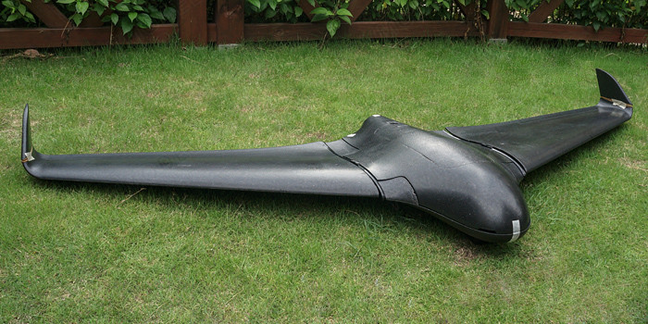

Figure Skywalker black X8 flying wing drone [2]

Table 4 represents a Pugh chart used for the selection of the motor configuration for a flying wing drone. The datum concept is a single motor mounted on the nose of the drone and three other concepts were compared to it. The three additional configurations included a rear motor, duel wing mounted motors and duel wing motors with an additional nose mounted motor.

Table   
 Motor Configuration Pugh Chart

|  |  |  |  |  |  |  |
| --- | --- | --- | --- | --- | --- | --- |
|  |  |  | Concepts | | | |
| Criteria | Weight  (0-5) | Nose  (datum) | Wings | Nose and Wings | One Rear | Two Rear |
| Aerodynamics | 5 |  | - | - | 0 | + |
| Yaw Control | 5 |  | + | + | 0 | + |
| Cruise Speed | 1 |  | + | + | 0 | - |
| Power Consumption | 5 |  | - | - | 0 | - |
| Ease of Construction | 3 |  | - | - | 0 | - |
| Durability | 3 |  | - | - | + | + |
| Cost | 3 |  | - | - | 0 | - |
| Score |  |  | -13 | -13 | 3 | 2 |
| Continue? |  |  | No | No | Yes | Yes |

The results above yield that using wing motors would not be a feasible design for the requirements of this project. The elimination of the wing motors leaves the option for a rear or nose mounted motor. Due to the variance in durability of the two configurations, a rear mounted motor was chosen for this design. The reasoning for choosing a rear mounted motor over a nose motor is because a nose mounted motor is more susceptible to damage in the event of a crash. The decision for whether to use one or two rear motors will come down to how difficult controlling the yaw of the drone will be in flight. If substantial control becomes necessary, then two motors will be needed.

Airfoil shape is an important mechanical property of an aircraft. The airfoil shape strongly affects the lift, drag, moment, and stall characteristics which will affect the aerodynamics of the vehicle as a whole. To capture the importance of the airfoil shape in the vehicle, Pugh charts were created to compare the various airfoil shapes. Previously, in the concept generation section, 4 airfoil shapes were introduced; NACA 0012, NACA 1408, NACA 63(2)-615, and Dillner 20-32C Airfoil. Figures 4,5,6 and 7 show visual representations of each airfoil shape discussed. The following Pugh charts compare the characteristic of the airfoils in the process of selecting the most practical shape for this design. The criteria on the Pugh chart was selected due to their effects on the aerodynamics of the vehicle.

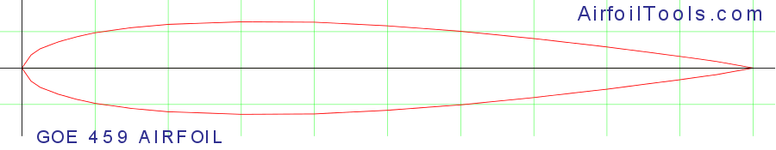

Figure NACA 0012 airfoil [3]

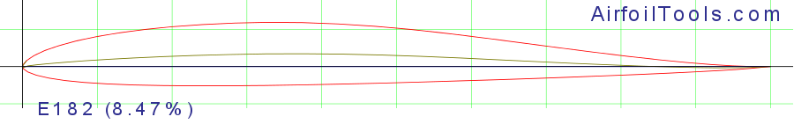

Figure NACA 1408 airfoil [3]

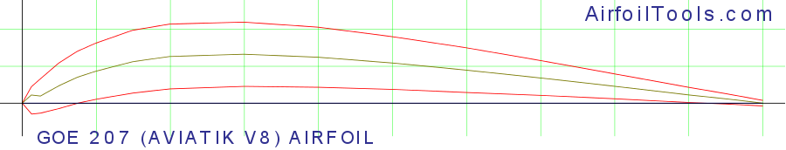

Figure 20-32C airfoil [3]

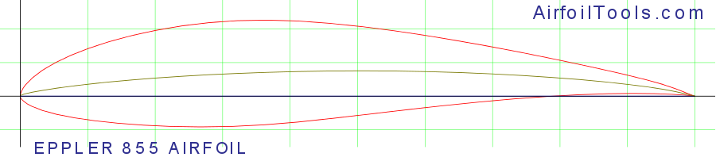

Figure NACA 63(2)-615 airfoil [3]

Table   
Airfoil Shape Pugh Chart 1

|  |  |  |  |  |  |
| --- | --- | --- | --- | --- | --- |
|  |  |  | Concepts | | |
| Criteria | Weight  (0-5) | NACA 0012  (datum) | NACA 1408 | 20-32C Airfoil | NACA 63(2)-615 |
| Lift | 5 |  | 0 | 0 | + |
| Drag | 5 |  | 0 | - | - |
| Moment | 2 |  | + | + | + |
| Stall Characteristics | 4 |  | 0 | + | - |
| Mass | 1 |  | + | + | - |
| Score |  |  | 3 | 2 | -3 |
| Continue? |  | Yes | Yes | Yes | No |

Since the NACA 0012 airfoil is the simplest airfoil, being mathematically similar to a flat plate, it was chosen as the datum for the chart. After comparing the airfoils in Table 5, the NACA 63(2)-615 airfoil was eliminated due to its poor stall characteristics and very high mass, which more than cancel out its good lift characteristics. Both the NACA 1408 and 20-32C airfoil are more mass efficient than the NACA 0012 airfoil while producing the same lift and having better moments. These three airfoils are compared once more in a second Pugh chart in Table 6 below.

Table   
Airfoil Shape Pugh Chart 2

|  |  |  |  |  |
| --- | --- | --- | --- | --- |
|  |  |  | Concepts | |
| Criteria | Weight  (0-5) | 20-32C Airfoil  (datum) | NACA 0012 | NACA 1408 |
| Lift | 5 |  | - | - |
| Drag | 5 |  | + | + |
| Moment | 2 |  | - | - |
| Stall Characteristics | 4 |  | - | 0 |
| Mass | 1 |  | - | 0 |
| Score |  |  | -7 | -2 |
| Continue? |  | Yes | No | No |

For the second Pugh chart, 20-32C airfoil was set as the datum because in the previous Pugh chart, this airfoil differed the most to the NACA 0012 airfoil. In summary, the NACA 0012 airfoil was better than the datum in 1 area, while it was worse than the datum in 4 areas. The NACA 1408 airfoil was better than the datum in 1 area, and worse than the datum in 2 areas. Since both of these airfoils were worse than the airfoil in more areas than they were better, it was decided that the 20-32C airfoil is the best airfoil choice for the vehicle.

The previous created, “Saurus”, used a carbon fiber frame. Saurus, being a multirotor drone, has different aerodynamic capabilities compared to that of a flying wing drone and therefore more materials were examined for the use of this design. Carbon fiber was used as the datum reference in Table 7 due to its decently low density, and high strength. Environmental durability was chosen as a criteria due to the excessive amount of flight time this vehicle will be exposed to in high temperatures. Ease of construction was chosen to show the manufacturability of each material, as the shape of wings will need to be molded to the previously selected airfoil.  The results of the Pugh matrix are discussed below.

Table   
Material Selection Pugh Chart

|  |  |  |  |  |  |  |  |
| --- | --- | --- | --- | --- | --- | --- | --- |
|  |  |  | Concepts | | | | |
| Criteria | Weight (0-5) | Carbon Fiber  (datum) | Foam | Epoxy Fiberglass | PLA Filament | Aluminum | PVC |
| Density | 5 |  | + | 0 | + | - | + |
| Impact  Strength | 4 |  | - | - | - | - | - |
| Environmental Durability | 2 |  | - | 0 | - | - | - |
| Ease of Construction | 3 |  | + | 0 | + | - | 0 |
| Ease of Repair | 4 |  | + | 0 | + | + | - |
| Cost | 3 |  | + | + | + | + | + |
| Score |  |  | 9 | -1 | 9 | -7 | -2 |
| Continue? |  | Yes | Yes | No | Yes | No | No |

With the results from the Table 7, the Pugh chart for material selection, carbon fiber, foam and PLA filament were further examined. Although carbon fiber has high impact strength and durability, the cost of the material outweighs the benefits of strength. The high strength of carbon fiber would be excessive for the requirements of this design. Eliminating carbon fiber from the choices of materials leaves foam and PLA filament, a material used in 3-D printing. Both materials scored equally on the Pugh chart when compared to carbon fiber, but there are significant benefits to using foam opposed to PLA filament. Foam is extremely easy to repair, especially in the field. Damage to a drone made of PLA filament would require maintenance in a shop which takes time and would cause a delay in a search and rescue mission, whereas foam could be repaired on site. Also, PLA filament does not handle high temperatures well and faces the risk deformation when exposed to high temperatures. With the aid of the Pugh chart and further examination of the materials, foam was chosen as the most functional material for the design.

In the concept generation phase several microprocessors were considered to handle the image processing for the new drone including Raspberry Pi 2, Raspberry Pi 3 model B, Raspberry Pi 3 model B+, NVIDIA TX1 and NVIDIA TK1. The previous drone used an NVIDIA TX1 as the main processor. This computer was used to handle all of the image processing while also communicating with the flying hardware when needed. The NVIDIA TX1 was used as the datum reference in Table 8 due to its low power consumption, medium weight, and high processing ability. Power requirement was chosen as a criterion because of its importance due to the power management on the drone. Power consumption was chosen as a criterion because of the necessity of reducing this factor due to the requirement of longer flight time for the drone. Size and mass are also two very important criteria to look at because of the limited space available in the drone for the components and the limitations on the weight of the drone. The last criterion consists of the processing power and memory available on the board. This criterion is vital because it relates directly to the ability of the processor to manage the image processing needed for the drone.

Table   
Processor Pugh Chart 1

|  |  |  |  |  |  |  |
| --- | --- | --- | --- | --- | --- | --- |
|  |  |  | Concepts | | |  |
| Criteria | Weight  (0-5) | NVIDIA TX1  (datum) | NVIDIA TK1 | Raspberry Pi 3 B | Raspberry Pi 3 B+ | Raspberry Pi 2 model B |
| Power Requirement | 3 | 5.5-19.6V, 4A max | 0 | + | + | + |
| Max Power Consumption | 5 | 10W | 0 | + | + | + |
| Size | 2 | 85.60 mm × 53.98 mm | + | + | + | + |
| Mass | 2 | 144 g | 0 | + | + | + |
| CPU and Memory | 5 | 1.73GHz and 4GB LPDDR4 | - | - | - | - |
| Score |  |  | -4 | 7 | 7 | 7 |
| Continue? |  | Yes | No | Yes | Yes | No |

From the first iteration of the Pugh method, various different processors were viable being the processor of the drone. These were the NVIDIA TX1, the Raspberry Pi 3 B+, and Raspberry Pi 3 B. The concepts excluded in the first iteration of the Pugh chart represented processors that could work, but when compared to the others they lacked essential capabilities to compete. These exclusions were based primarily from power consumption and processing speed. The second iteration of the Pugh chart was executed using the Raspberry Pi 3 B+ as the datum because of its score from the previous chart and its different characteristics when compared to the NVIDIA TX1.

Table   
Processor Pugh Chart 2

|  |  |  |  |  |
| --- | --- | --- | --- | --- |
|  |  |  | Concepts | |
| Criteria | Weight  (0-5) | Raspberry Pi 3 B+  (datum) | NVIDIA TX1 | Raspberry Pi 3 B |
| Power Requirement | 3 | 5V and 2A | - | + |
| Max Power Consumption | 5 | 5.6 W | - | 0 |
| Size | 2 | 82mm x 56mm x 19.5mm | - | 0 |
| Mass | 2 | 50g | - | 0 |
| CPU and Memory | 5 | 1.4GHz and 1GB LPDDR2 | + | - |
| Score |  |  | -7 | -2 |
| Continue? |  | Yes | No | Yes |

With the results from Table 9, the Raspberry Pi 3 B+, the Raspberry Pi 3 B, and the NVIDIA TX1 were further examined. In the case of the NVIDIA TX1, the only criteria that proved better when comparing it to the datum was the CPU and memory. Although this criterion is very important, the high-power requirement and max power consumption outweighs the benefits of having very good CPU and memory. After excluding the TX1 board, the only two options left which were the Raspberry Pi boards. In this case, the previous iteration of the Raspberry Pi 3 B+ board has slightly better max power consumption and power requirements, but fails at everything else. In the end, the Raspberry Pi 3 B+ was chosen as the main processor because of its great performance coupled with great power qualities and perfect size and weight.

The selected camera for the drone needs to have certain elements to attain the highest detection accuracy for the image processing. This camera needs to provide consistent and reliable images using a 720p resolution because of the data rate and power consumption requirements. The previous drone used the Logitech C920 HD PRO as the main camera. This component was successfully used and tested for the image processing in the previous drone. For this reason, the Logitech C920 HD PRO was used as the datum for Table 10. Weight and size were chosen as criteria because of the weight requirement for the drone and the limited space for components available in the drone. The next criterion chosen was HD recording; This criterion is very important because the drone needs a camera that is able to record and transmit video at 720p. The last criterion for Pugh chart was chosen to be still photo resolution. This criterion is vital because the camera needs to able to produce reliable images for the image processing.

Table   
Camera Selection Pugh Chart

|  |  |  |  |  |  |
| --- | --- | --- | --- | --- | --- |
|  |  |  | Concepts | |  |
| Criteria | Weight  (0-5) | Logitech C920 HD PRO  (datum) | GoPro Hero 7 Silver | Polaroid Cube + | Kodak Pixpro S360 |
| Weight | 3 | 162g | + | + | + |
| Size | 1 | 94 mm x 24 mm x 29 mm | + | + | + |
| HD Recording | 4 | 720p/30fps | + | - | - |
| Still Photo Resolutions | 5 | 15MP | - | - | + |
| Score |  |  | 3 | -5 | 5 |
| Continue? |  | Yes | Yes | No | Yes |

With the results from Table 10, there are three main concepts that were further examined for the selection of the camera. In the case of the GoPro Hero 7, the camera offers good weight, size, and HD recording. Although the GoPro Hero 7 has high still photo resolution, the concept falls short when compared to the datum. The next camera considered for the drone was the Kodak Pixpro. This concept excels in three out the four criteria considered but when compared to the datum it falls short on the HD Recording which is a vital part of the design. The last option for the camera would be the one used in the previous drone, the Logitech C920 HD PRO. This camera falls short in the weight and size criteria, but excels in the still photo resolution and HD recording. Using this camera for the new design also means that the cost of the camera can be neglected because this component will be taken from the previous drone. With the aid of the Pugh chart and further examination of the selected cameras, the Logitech C920 HD PRO was chosen as the most practical camera for the design.

The power management needs to be simple to design and implement, due to the time constraints of the project. The fly buck boost topology was put as the datum because its design was simply a chip and a few other components. The output power available for each topology differs, and each one does a different function. The input voltage range is slightly important, because the batteries that will be used will change in voltage. Most topologies account for this though, so it is only slightly important. The power output is very important, since not all topologies can yield the required current at a low voltage. The required current is high due to the motors and the processor requiring high currents. The accessibility is important, since control chips are designed for specific applications in mind, and will not always bend to the design parameters.

Table Power Management Pugh Chart

|  |  |  |  |  |  |
| --- | --- | --- | --- | --- | --- |
|  |  |  | Concepts | |  |
| Criteria | Weight  (0-5) | Fly Buck Boost  (datum) | Fly Buck | Buck Boost | Buck |
| Input Voltage Range | 2 |  | 0 | - | - |
| Simplicity | 4 |  | - | 0 | 0 |
| Power Output | 5 |  | 0 | - | + |
| Accessibility | 3 |  | 0 | + | + |
| Score |  |  | -4 | -4 | 6 |
| Continue? |  | No | No | No | Yes |

Upon researching synchronous buck boost and buck converters, the buck boost and buck topologies became significantly better for the design of the power management. The fly buck converter is very similar to the fly buck boost, but since it becomes more complex with additional outputs, it is worse than the datum. The buck boost converter is very accessible, but is not rated well for low voltage high current situations. The synchronous buck converter not only appeals to the design parameters, but the chips for it plentiful and flexible. All options fall short compared to the synchronous buck converter, so the buck topology was chosen.

From the concept generation phase, several communication modules were considered for the design. These were the XBEE Pro 900 HP, the TI CC1312R, the XBEE Pro SX and the XBEE SX RF. The communication modules need to provide reliable data transfer with a very long range and low power consumption. The XBEE Pro 900 HP was picked as the datum for the communication Pugh chart because it was tested previously, and it had a good performance. Bandwidth was picked as a criterion because having a reliable bandwidth is related for data transfer. Output power is another very important part of a communication module because it is one of the parameters that sets the range of the communication system. The next criterion chosen was data rate, this criterion is also involved in the signal strength calculations. Sensitivity is the most important criterion for the system. The sensitivity is directly correlated to the range, so the range criteria was replaced with receiver sensitivity. The last criterion was chosen to be features which are the extra characteristics that each module has to offer, such as being programmable or configurable.

Table   
Communications Pugh Chart

|  |  |  |  |  |  |
| --- | --- | --- | --- | --- | --- |
|  |  |  | Concepts | |  |
| Criteria | Weight  (0-5) | XBEE Pro 900 HP  (datum) | TI CC1312R | XBEE Pro SX | XBEE SX RF Modem |
| Bandwidth | 1 |  | 0 | + | - |
| Output Power | 3 |  | + | + | - |
| Data Rate | 4 |  | 0 | - | + |
| Sensitivity | 5 |  | + | + | - |
| Features | 2 |  | + | - | + |
| Score |  |  | 10 | 3 | -3 |
| Continue? |  | No | Yes | No | No |

With the results from Table 12, there is only one option that fulfills the requirements of the communication module for the design. The TI CC1312R was the final concept selected because it had the best score when compared to the other XBEE communication modules and the datum. The TI CC1312R excels in being programmable and configurable, which it will allow various modes and data ranges. The TI transceiver also has the best sensitivity, which significantly increases the range! The transceiver has average data rate, but everything else about it exceeds the other communication systems, making it the chosen system.

In summary, based on all of the Pugh charts and the comparisons that were conducted, it was decided to create a fixed wing drone that has a flying wing for its body type, and foam for the material. The 20-32C airfoil shape will be implemented for the wings and the motor will be mounted in the back, in a pusher configuration. For the communications, the TI CC1312R MCU was chosen as the main communication module. It will be paired with a high gain Yagi antenna at the ground station, and an omnidirectional antenna on the drone itself. The processor will be Raspberry Pi B+ and will handle all of our processing needs, including the flight controller. All of this will be powered by one 3s battery. The buck converter topology was the one decided on at the end because it was the most optimizable, as well as it is simple to implement and buy. The selections for each component of the design are organized in Table 11 below.

Table   
 Final Selection Table

|  |  |
| --- | --- |
| **Component** | **Selection** |
| Vehicle Choice | Flying Wing |
| Motor Configuration | Rear |
| Airfoil | 20-32C |
| Material | Foam |
| Power Management Systems | Buck Topology |
| Communications | TI CC1312R MCU |
| Processor | Raspberry Pi 3 B+ |
| Battery Type/Number of Batteries | 1 3s Battery |
| Camera | Logitech C920 HD PRO |

## Spring Project Plan

The following milestones represent a timeline of the tasks that need to be completed in spring. Major tasks include prototype assembly, design testing, alterations, presentations, and engineering design day, where the final project will be presented. The final project must be completed in April to prepare for the final presentation. Included along with the milestones is a Gantt chart, Figure 8, that puts all the tasks for spring onto a visual representation.

Milestone 1: Beginning of the Spring semester

* Set up a team meeting to discuss the next steps for the project
* Document the new available times for each of the team members
* Contact Mr. Merrick to check if the parts ordered have arrived, or when they will arrive
  + Update BOM regarding status of parts

Milestone 2: January 15

* Prepare 1st spring presentation
* Begin testing the communication system
* Make any changes to the previous assignments if necessary
* Begin the preparation of the mechanical parts of the drone
  + Prepare laser cut guides for cutting the wings
  + Assemble hot wire cutter, test effectiveness
* Attend STEM day

Milestone 3: January 29

* Advisor meeting 1
* Prepare 2nd spring presentation
* Begin to assemble the prototype
  + Cut wings using hot wire cutter
  + Initial cut for the fuselage

Milestone 4: February 28

* Advisor meeting 2
* Prototype testing

Milestone 5: March 16

* Spring Break - March 16th-20th

Milestone 6: March 31

* Create final project poster/presentation

Milestone 7: April 18

* Engineering design day
* Final team presentation
* Final meeting with advisor

Milestone 8: April 29

* Finals week

Milestone 9: May 3

* Graduation May 3rd-4th

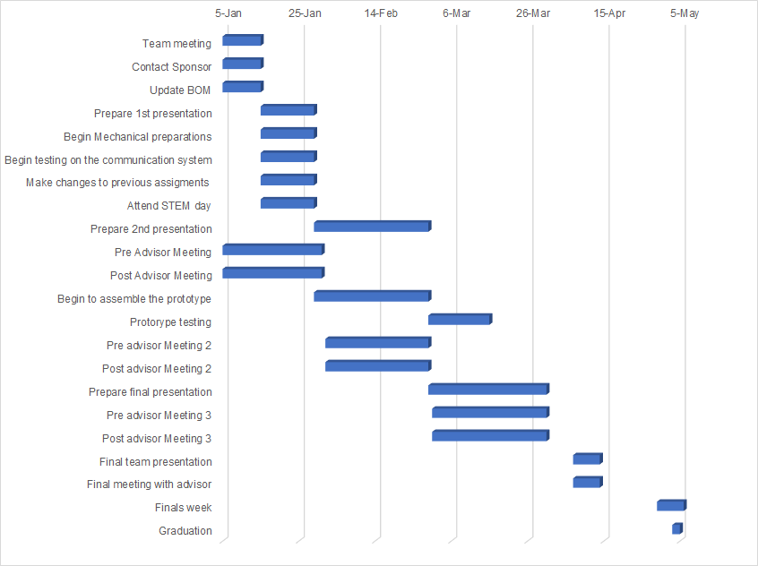

Figure Gantt Chart Spring 2019

Table 14 wraps up the summary of tasks to be completed in spring for both the mechanical and electrical side

Table   
Summary of Tasks

|  |  |
| --- | --- |
| Electrical To-dos   1. Test camera & image processing software 2. Test communications 3. Assemble electrical parts in smallest possible footprint 4. Test part interface 5. Test autonomy | Mechanical To-dos   1. Make hot wire cutter 2. Create & laser cut guides 3. Cut wings and fuselage 4. Test motors and servos 5. Streamline fuselage after electrical footprint is determined 6. Assemble drone 7. Test drone |

# Chapter Two: EML 4552C

## 2.1 Restated Project Scope

The current iteration of the client’s drone, while functional, is not practically useful and needs to be improved to be effective. In particular, the range, flight time, and camera stabilization are of vital importance. Moreover, the client has also requested a number of improvements to the user interface, including autonomous flight. The design must be made with reliability and longevity as primary characteristics. If successful, this drone design could be used not only in emergency situations, but also for general wide-area searching.

The primary users of this design will be the Department of Emergency Management and Homeland Security (EMHS), but could also be used by various organizations including the FBI for kidnapping cases, conservation groups for counting animals, and penitentiaries to aid in the capture of prisoner escapes. The final product of this design will also be able to aid in environmental disaster surveys and reliefs. The city of Tallahassee could be a tentative stakeholder for this project. Several departments such as the police and the fire department would benefit from having an Emergency Management Drone at hand for situational purposes.

### 2.1.1 Key Goals

The key goal of this project is to create a drone that can search a large area of land efficiently and quickly. While in use the drone must be able to communicate with at least one device on the ground. While the previous drone is available, it is not required to use primary aspects of its design. It must be able to be easily moved by hand or by car when not in use. Most importantly, the modifications must be completed by April 2019.

### 2.1.2 Markets

A variety of drones can be utilized for emergency management situations. Drones allow the use of emergency management personnel to evaluate a situation using aerial footage to reduce the risk of endangering humans while examining a hazardous scene. Although the drones used for each situation vary, there are similar markets to the FSU’s Department of Emergency Management all of which utilize the use of drones. Every state in the United States has an Emergency Management Department or a Bureau of Homeland Security. Along with state agencies, the US Department of Homeland security provides emergency management on a national level. Private companies such as Global Rescue and Medjet also provide assistance in medical, security and crisis response situations. Although there are different markets for emergency management and homeland security, there is very little competition between each department seeing that in the case of an emergency state local and national departments will work together to safety manage a dangerous situation. As for the private companies, personnel must purchase a membership to be insured for their assistance in the case of an emergency. Those who purchase memberships usually do so before traveling or participating in an activity that has the risk of needing emergency medical assistance. Global Rescue and Medjet work on a global scale for individual and government needs.

### 2.1.3 Assumptions

It is assumed that the vehicle will be battery powered and it will be able to operate at a safe distance. It is also assumed that the vehicle will need to be able to scan a designated area for objects. Once these objects have been found, it is assumed that the vehicle will then tag the area for further search that will be performed through other means. It is also assumed that the vehicle will be easily repairable and user friendly, since the vehicle will be needed in contexts ranging from local to state needs.

### 2.1.4 Stakeholders

All parties to be affected by the success of this product include our sponsor (David Merrick), advisor (Rodney Roberts), overseeing professors (Shayne Mcconomy and Jerris Hooker), and any persons who would rely on the drone in the case of an emergency. The success of this product will be taken very seriously to ensure that all of the stakeholders are not negatively affected.

# 2.2 Results

## 2.2.1 Experimental Flight Results

During testing, the drone was launched three times and did not have enough thrust at launch to climb to altitude in all three cases. Because of this, it was impossible to test how well it flew at steady state. However, what the failed launches did reveal was that the motor produced a lot more torque than was anticipated, though this was mitigated by applying opposite aileron. With each landing, the drone took moderate but repairable damage to the frame, except in the last launch where the propeller snapped during a belly land. The electronics were not harmed during any of the crashes.

## 2.2.2 Power Management Results

In order to test the efficiency of the power converter, the input and output powers must be obtained from the power converter. A multimeter was used to measure the output voltage and current, while an adjustable power supply was used to set and record the input voltage and current. The first test was to test power on a Raspberry Pi 3B+ without running any background processes. The efficiency of the power converter was recorded to be around 75%, which resulted in an error of 26.6% when compared to the rated efficiency of 93%. Since the converter is rated for a max current of 8 amps, and the output current of the test was less than 1 amp it was concluded that there was a sufficient drop in efficiency. The second test powered an additional microprocessor, an Arduino Uno, to simulate handling a higher load. There was a slight increase in efficiency (80%), since the output current was about 1 amp. This efficiency was deemed efficient for the power management on the drone since the power consumed from the processors and Pixhawk is significantly less than the power consumed from the motor.

## 2.2.3 Communication System Results

Multiple tests were done with several different prototypes, and as mistakes were found they were fixed with a redesign of the system.  The first test used the TI CC1310 communication boards. A pre-built software from TI, SmartRF Studio, was used to run a test script that sent random packages from one board to the other, while also giving Received Signal Strength Indicator (RSSI) values and bit errors. The test was done at Alligator Point beach to test the maximum range of the communication system at a data rate of 50 kilobits per second while keeping below 0.2% bit error rate (BER). The objects used were a Yagi antenna, an omnidirectional antenna, a portable battery, a multirotor drone, and the two CC1310 transceivers.  The resulting range was around 2 km from the ground to an altitude of 300 ft. The team discovered later that the TI boards were not able to be interfaced with the Raspberry Pi without flashing an operating system not supported for the object detection libraries. The LoRa communication modules were then implemented as the operating communication system. To test the LoRa modules, a script was created along with the implementation of libraries to interface with the board. The first test used the Radiohead libraries with a python wrapper, which included a customizable and effective bit error correction.  After many weeks of attempting to implement it, the team moved on to use Adafruit’s RFM9x libraries. The python script used to test sending PNG images through the LoRa modules proved to be successful, but not without flaws. A ground to ground test using the same objects from the first test (without the drone) was done along Orange Avenue close to the College of Engineering campus. This distance was around a mile, but it was difficult to receive packages due to a limited line of sight and destructive interference caused from both sides being on the ground. A final test was done near the College of Engineering, achieving around a distance of 0.6 kilometers. This distance is not the maximum distance achievable, even for ground to ground communication.  Further testing needs to be done to find the experimental maximum distance.

Other test results included achieving 3/6 error free sent images at an RSSI of -85 dbm and a rate of around 3 kilobits per second. The tests were successful only a handful of the time due to the lack of error correction from the Adafruit libraries.  When a packet contained an error, the rest of the image was corrupted, making the rest of the image black. This was caused due to the compressed nature of the PNG format.

## 2.2.4 Image Processing Results

Image processing results were mainly based on the performance of the weights trained for the neural network. There are several factors that we had to consider in order to quantify the performance of the neural network. These factors include precision, recall, Intersection over Union (IoU), and the mean average (mAP). Precision is the proportion of targets identified from a positive frame. For the tiny Yolov3 weights trained this value as 0.67, which represents a precision of 67%. Recall represents the proportion of positive frames that had targets identified correctly. Testing resulted in a recall value of 0.47, corresponding with a recall of 47%. Both precision and recall were based on a threshold of 25% meaning that the neural network will only classify the object if its 25% confident that this object is a person. Intersection over Union (IoU) is a very important performance parameter. IoU measures the overlap seen between two boundaries, meaning it compares the actual label of the image with the one that the neural network predicts. The IoU value was 44.28% which almost reached the ideal value of 50%. The mean average (mAP) which measures the accuracy of the neural network and resulted in a value of 0.494 during testing concluding that the weights selected had a mAP of 49.4%. These values can be seen in Figure 9 where the calculations are displayed. Unfortunately, there were no test done in which the neural network was tested on the drone due to the failed flight tests. Even without testing the neural network from an aerial POV, the ability for the network to detect objects from a high altitude is very promising. The tests done from a lower altitude (where images were taken from a 3-story building) the neural network was able to identify the target and save the frame in every test.

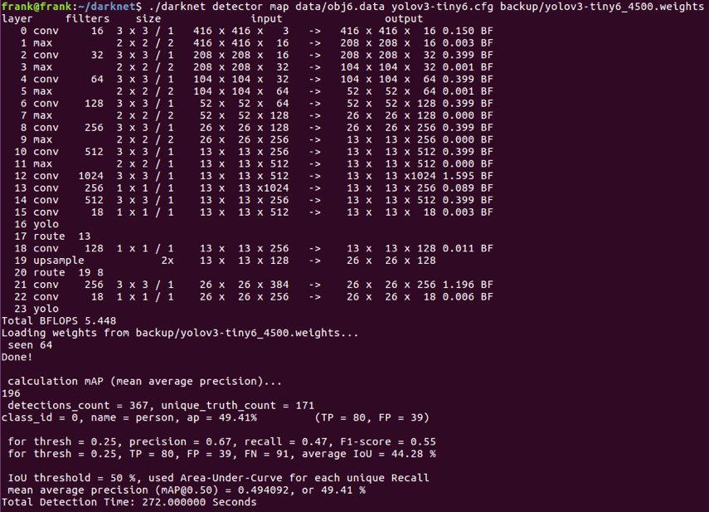

Figure Tiny Yolov3 Training Results

# 2.3 Discussion

From the test launches, we found that the drone had an insufficient thrust to weight ratio (TWR) in order to take off in the expected manner. There are a number of factors that could have played into this; insufficient motor thrust, exceeded weight, insufficient lift generated by the wings, or too much drag generated by the body are all potential problems. While normal TWR values for takeoff are in the range of 0.8-1, and the TWR for our drone was about 0.8. These values are typically indicated for launching with a runway, and should have been adjusted to a higher value to launch the vehicle via a hand toss. Additionally, the control surfaces were hardly able to correct the high rolling moment at launch, meaning that they might have proven to be insufficient for many flight maneuvers. While the drone’s structure survived each crash, the large split on the nose during the second test indicates that the nose should have been tapered or rounded more to avoid stress concentrations.

The database used to train the neural network for this project used a total of 800 images, 600 negatives and 200 positives. The positives images were the ones that had a singular or multiple objects of interest for detection. The negative images did not have any objects of interest.  It is important to have both negative and positives images for a more diverse and complete training. To create this database three videos were recorded in different forest environments. After the recording of the videos, one frame per second of each video was saved and then divided into four tiles of the same size to create more pictures for the database. To complete the database, labels for each image were needed in order to start training. A labeling software was used to label these images in the darknet format. The darknet format is the format used for labeling the object in the images. When the database was completed, it was divided into three different sets that had both positives and negatives frames. These sets were training (used to train the neural network), validation (used to validate results in the training process) and test (used for checking the results of the trained weights). Our database had 586 training images (73.25%), 146 validation images (15.25%) and 68 test images (8.5%).

From the analysis done to the trained weights of the neural network, it was concluded that the training was successful because a max mAP of around 50% was reached. While the ideal mAP value is around 90%, archiving a mAP of 50% is decent for a data set that is small and not very diverse. To reach a higher value, it is necessary to use a more diverse data set with more images. The trained weights can be used to continue training with the new database, meaning the continued training does not have to start from scratch.

# 2.4 Conclusion

Although the initial prototype was not fully operational, most of the subsystems that were built are either complete or close to completion. There is continued work that needs to be done in order to make this an operational product, but this is now more a problem of optimization. While it cannot be said that this project was a complete success, it has been very enlightening in recognizing the challenges of building an integrated system of moderate complexity.

## 2.5 Future Work

Based on results discussed, there are a few issues that clearly need to be addressed. For example, in order to get the drone flying, weight needs to be decreased or a motor capable of producing more thrust needs to be put on. Alternatively, the body could be optimized to reduce drag and get higher initial acceleration. Another solution to getting the vehicle into the air may be to rework the launch system to include some type of sling-shot system. In order to switch to a higher power motor, the electrical system must be switched to a higher voltage system (ie. 5S or 6S). In order to reduce the risk of destroying the electronics connected to the power converter, the power converter will need to be modified so that it can handle the voltages produced by higher voltage batteries.

If moving to a higher voltage system is not possible, an additional motor with similar specifications will be needed to produce sufficient thrust. This specific solution is not ideal because it adds more weight to the drone, and also drastically reduces the available power for the rest of the electronic, overall decreasing flight time. However, adding another motor creates another method of controlling the drone through differential thrust, allowing the ability to yaw the drone. Additionally, the second motor can turn in an opposite direction to the first motor, cancelling out the rolling moment that was seen during flight tests.

If the power converter is supporting a higher cell battery, it would need to be redesigned to include a higher input voltage range. Also, further testing needs to be done to test the efficiency at a higher load by including all the devices connected.

The communication system should support higher data rates, but at most 50 kbps. It is important to optimize range over data rate, but it should also be feasible to send an image every 2-3 minutes. A bitmap format should be used over a compressed image, since compression can lead to sending broken images.  This will make the images a significantly larger size, but it is preferred over sending a corrupted image. The frames captured should be at a smaller resolution or quality. Our team could not find a way to capture frames at a smaller size without changing the already small resolution of 320x240. A solution to get the file size of each frame to be less than 100 kilobytes in bitmap format should be sought out. Also, more air to ground tests with both with and without line of sight need to be done to know the maximum range of all the subsystems.

Based on the current results of the neural network, more training is needed to reach a better level of performance. In order to achieve a better mAP a bigger and more diverse database is needed. This database should include around 6000 images from which 4000 should be negatives and 2000 should be positives. This ratio of positive and negative images should produce an optimal database for training the neural network. The positive images should include pictures of single and multiple targets and also many different colors so that the neural network has a diverse training regime. The database should also be divided accordingly for training, validation and test sets; a ratio of 60% for training, 25% for validation and 15% for testing will give the desirable results for detection. For this project, the tiny Yolov3 was used because of the size of our database. Having a database with the previous parameters will offer the perfect training regime for either the Yolov3 or the tiny Yolov3.

# Appendix A: Code of Conduct

**Mission Statement**

Senior design team 307, Emergency Management Drone, is committed to creating a work environment that supports open communication between FSU’s Department of Emergency Management and our team.  We are committed to providing a high-quality product that exceeds any client’s expectations.

**Roles**

Each team member is delegated a specific role based on their experience and skill sets and is responsible for all here-within:

**Team members:**

**Project Manager – Haley Barrett**

Haley is a senior undergraduate student at Florida State University. She is responsible for coordinating all team meetings and maintaining communication between the group. She will complete revisions of all reports before they are turned in and create an organized agenda of upcoming deadlines to be shared with all group members.

**Financial Advisor – Juan Patino**

Juan is senior undergraduate student studying electrical engineering at Florida State University. He is responsible for maintaining organized records of all credits charged throughout the project. He will maintain communication with the sponsor, The Department of Emergency Management at FSU, and the College of Engineering while purchasing parts and components pertaining to the project.

**Lead ME – Kody Koch**

Kody, a senior in mechanical engineering study will take the role as the ME lead. He coordinates the mechanical side of the project, and is responsible for all the mechanical details of the design. He also helps coordinate the mechanical departments interactions with the electrical department in order to work more efficiently. Kody also assist with MATLAB and C++ coding along with refactoring.

**Lead ECE – Matthew Roberts**

Matthew is a senior undergraduate student studying Electrical Engineering at Florida State University. He also is an intern under the City of Tallahassee Utility Power Division, and as an undergraduate researcher at CAPS, researching Power Electronics under Dr. Li. He is responsible of the EE, IE, or CE design part in support of the project. He maintains line of communication with the lead ME, and manages the construction of the project circuitry.

**Lead Designer/Aerodynamic Engineer– Josh Reid**

Josh is an undergraduate senior at Florida State University studying Mechanical Engineering. As the Lead Designer and Aerodynamic Engineer, he works to ensure that all aerodynamics are accounted for in the design of the aircraft, while also developing any additional CAD designs needed for the aircraft.

**Lead Programmer/Web Developer– Francisco Silva**

Francisco (Frank) studies electrical engineering at Florida State University with focus in microprocessors and electronics. As the lead programmer, Frank is in charge of developing the team’s website and keeping it up to date with current progress of the project. Along with the help of the other engineers, Frank will take lead on image processing and electronics.

**All Team Members:**

-Provide input to all aspects of the project

-Show effort in areas of the project that are not their expertise

-Delivers on commitments

-Listen and contribute constructively

-Put forth best effort to be present at all group meetings

-Be open minded to others ideas

-Respect others roles and ideas

**Communication**

The main form of communication will be through the app Discord, a group messaging platform. The group will stay in contact weekly as needed, and will meet in person once a week at the minimum. Constant communication within the group is a successful tool for timely completion of tasks for the project.

Communication with advisors, sponsors and reviewers will be done mainly through email, but in person meetings will take place as needed with respect to attendee’s schedules.

**Team Dynamics**

Open communication is encouraged between group members, and nobody’s ideas should be discouraged before discussion. Teamwork and cooperation are a key focus between group members.

**Ethics**

Team members are required to follow NSPE Engineering Code of ethics as they are responsible for their obligations to the public, the client, the employer, and the profession.

**Dress Code**

Team meetings will be held in casual attire, whereas meetings with sponsors, advisors and reviewers will require business casual attire. Dress code for presentations will be held in business attire.

**Attendance Policy**

Team meetings will be held weekly on Tuesday or Thursday afternoons at the earliest convenience after the ME’s senior design class. Throughout the week the group will maintain communication and meet in person as needed. If a member of the group fails to meet excessively, the matter will be brought up to the instructor pertaining to that student’s engineering discipline.

**Decision Making**

In efforts to create a fair decision-making policy, a voting system will be implemented where majority is in favor. Input of all students in the group will be required to dictate an equitable decision.

**Conflict Resolution**

In the event of a disagreement between a member of team 307 the following actions will be implemented:

-A group meeting will be scheduled to administer a group vote, favoring the majority.

-If a member of the group is still dissatisfied, an instructor will facilitate a resolution.

**Statement of Understanding**

By signing this document, the members of Team 1 agree the all of the above and will abide by the code of conduct set forth by the group.

|  |  |  |
| --- | --- | --- |
| Name | Signature | Date |
| Haley Barrett |  | 09/12/18 |
| Kody Koch |  | 09/13/18 |
| Juan Patino |  | 09/13/18 |
| Joshua Reid |  | 09/14/18 |
| Frank Silva |  | 09/14/18 |
| Matthew Roberts |  | 09/16/18 |

# Appendix B: Functional Decomposition

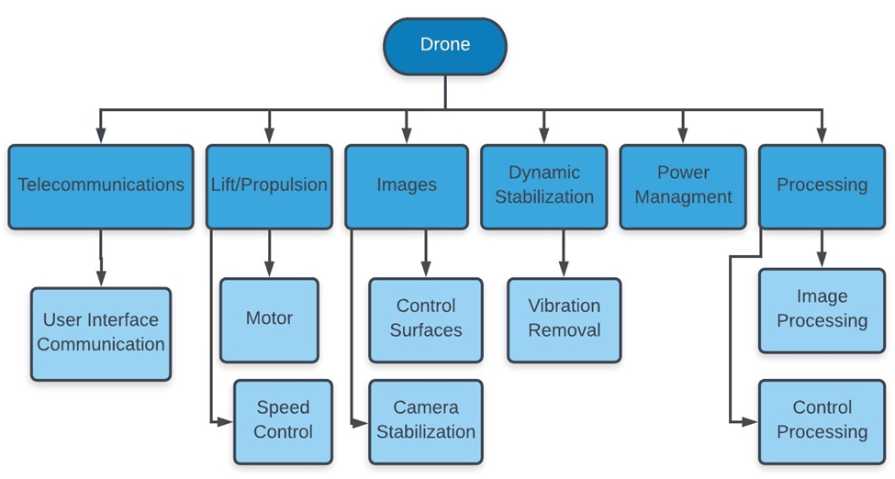

# Appendix C: Target Catalog

|  |  |  |  |  |  |  |
| --- | --- | --- | --- | --- | --- | --- |
| Target  No. | Need | Metric | Weight  (1-5) | Units | Marginal Value | Ideal Value |
| 1 | Increased range | Range | 5 | km | 1 | 2 |
| 2 | Longer flight time | Flight time | 5 | min | 20 | 30 |
| 3 | Clear images transmitted to ground device | Camera Stabilization | 4 | % | 80 | 100 |
| 4 | Longer flight time | Cruise Speed | 1 | km/h | 30 | 25 |
| 5 | Longer flight time | Power consumption | 5 | W | 150 | 125 |
| 6 | Autonomous flight options | Levels of autonomy | 4 | % | 50 | 80 |
| 7 | Longer flight time | Drone weight | 3 | kg | 2.8 | 2.5 |
| 8 | Longer flight time | Payload capacity | 3 | kg | 1.5 | 1 |

# Appendix D: House of Quality

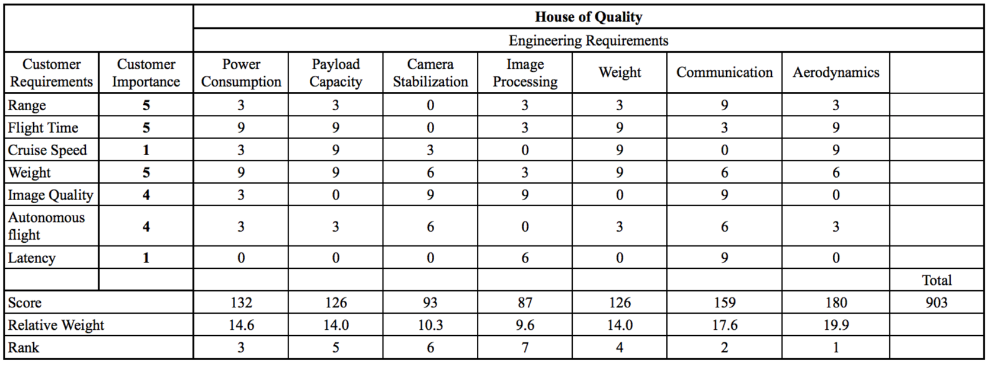

# Appendix E: Calculations

## Aerodynamic Calculations

## The following calculations were used to calculate specific aerodynamic properties of the wings. The constants used in each equation are represented in Table 15.

Table Parameters for Aerodynamic Equations

|  |  |
| --- | --- |
| **Parameter** | **Description** |
|  | Coefficient of lift |
|  | Coefficient of drag (form) |
|  | Coefficient of drag (induced) |
|  | Coefficient of drag (skin friction) |
|  | Survey area |
| AR | Aspect ratio |
| s | Wingspan |
|  | Density |
|  | Viscosity |
|  | Velocity |
| h | Height |
|  | Steady-state velocity |
|  | Flight time |
|  | Field of view of the camera |

## Communication Equations

The following equations were used to calculate the theoretical results for the communication system. The parameters for these equations are represented in Table 16.

Table Parameters of Communication Equations

|  |  |  |
| --- | --- | --- |
| Parameter | Description | Value |
|  | Resulting sensitivity | -104.7 dBm or 3.39*mW |
| R | Data rate | 50 kbps (TI), 38.4 kbps (XBee) |
| N | Noise power | 3.695*mW |
|  | Probability of bit error | Dependent |
|  | Inverse tail distribution function | Dependent |
|  | Gain of receiver antenna | 3 dBi, 2 (HG Omni) |
|  | Gain of transmitter antenna | 10 dBi, 10 (HG Yagi) |
|  | Power transmitted | 15 mW |
|  | Height of receiver antenna (drone) | 115m |
|  | Height of transmitter antenna (base) | 1m |
|  | Other losses (fading, multipathing) | 5 dB |
| d | Maximum range of communication | 50 kbps |

# Appendix F: Engineering Drawings

The following images represent the Computer Aided Drawings (CAD) of the electronics box and the structure of the drone.

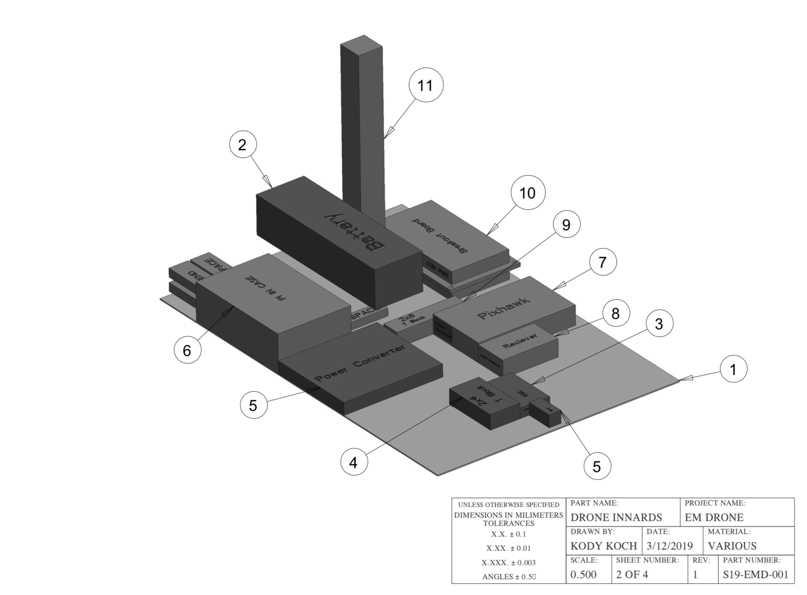

Figure Assembled View of the Electronics Box

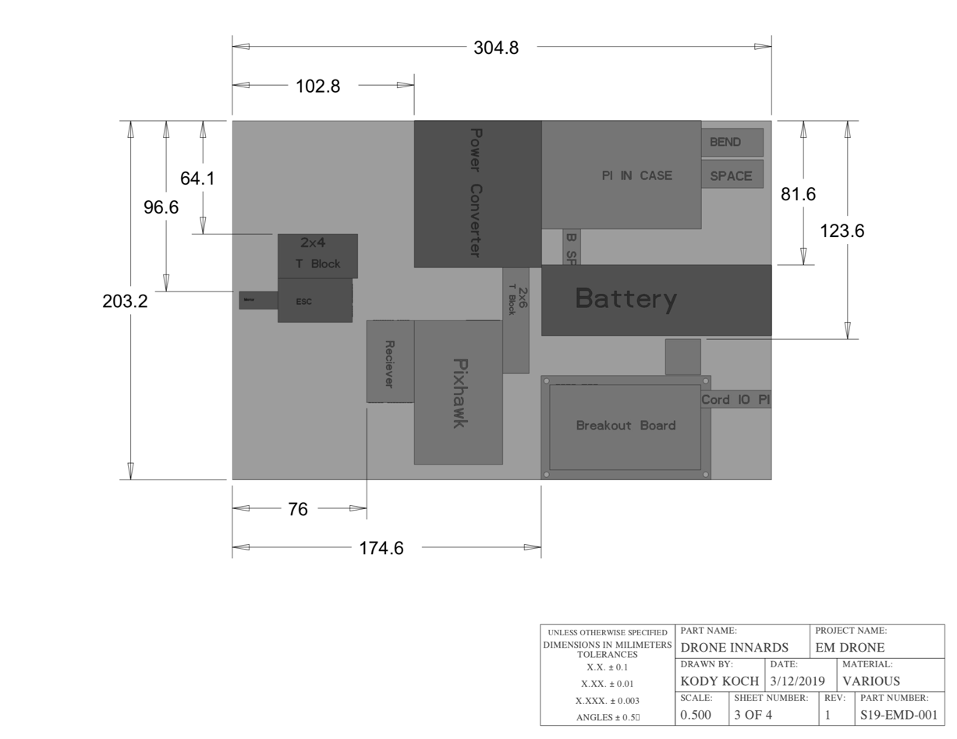

Figure Dimensions of Electronics Box

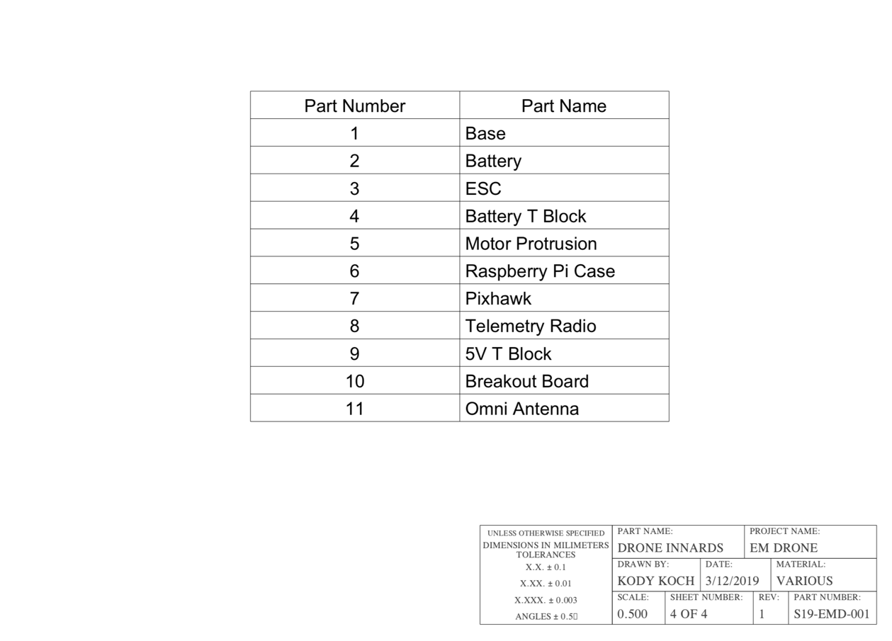

Figure Part Number Labels

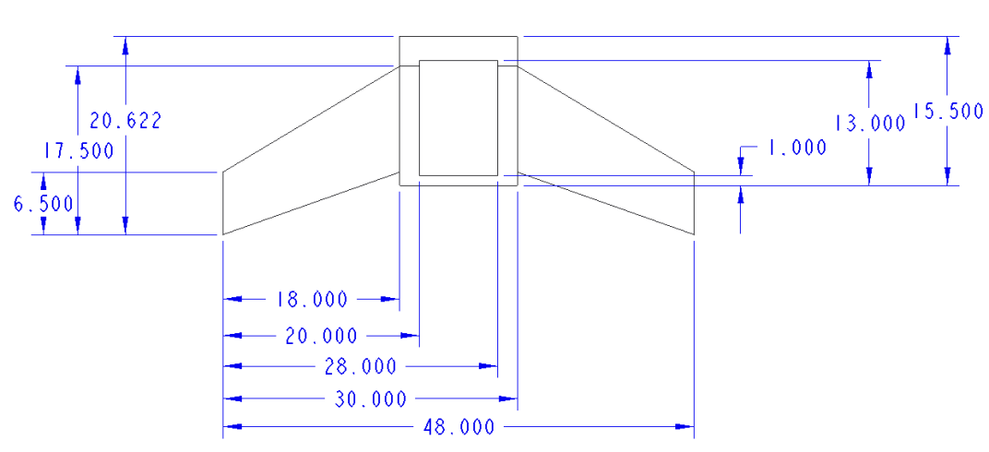

Figure Dimensions of the Airframe

# Appendix G: Aerodynamic Calculations Code

The following code utilizes the equations used in appendix E.

## Lift and Drag 1

1. %Header
2. clc
3. clear all
4. close all
5. %Knowns
6. m = 2.0; % Calculation mass
7. AR = 4; % Aspect Ratio
8. c = 0.4572; % Average in m
9. S = 36/39; % Wingspan in m
10. A = 0.8361274; % m^2
11. rhoair = 1.225; % kg/m^3
12. muair = 18.37e-6; % Pa*s
13. cl0 = 0.183;
14. cdf0 = 0.023;
15. % alphas = [0 1 2 6];
16. % cl0 = [0.183 0.27 0.42 0.8];
17. % cdf0 = [0.023 0.025 0.028 0.031];
18. v = linspace(0,20); % m/s
19. fov = 90; % In Degrees
20. h = [200, 300, 400];% Height in feet
21. ft = 30; % Flight time in minutes
22. %Calc Lift and Drag at 0 deg
23. Lift = cl0.*A.*0.5.*rhoair.*v.^2 -9.81*m;
24. FDrag = cdf0.*A.*0.5.*rhoair.*v.^2;
25. cds0 = 0.664./sqrt(rhoair.*v.*c./muair);
26. SDrag = cds0.*A.*0.5.*rhoair.*v.^2;
27. cdi0 = cl0^2/(AR*pi);
28. IDrag = cdi0.*A.*0.5.*rhoair.*v.^2;
29. Drag = FDrag + SDrag + IDrag;
30. %Plot
31. figure(1)
32. plot(v,Lift,v,Drag)
33. hold on
34. grid on title("Forces at \alpha = 0 deg")
35. xlabel("Velocity (m/s)")
36. ylabel("Force (N)")
37. legend("Net Lift","Drag")
38. hold off
39. %Estimate Survey Area & Plot vs height
40. hm = 0.3048.*h; % Convert to m
41. vtrim = v(find(abs(Lift) < 0.5, 1, 'first'));
42. surveyarea = vtrim.*2.*hm.*ft.*60;
43. figure(2)
44. plot(h, surveyarea)
45. hold on
46. grid on
47. title("Survey Area vs Height")
48. xlabel("Altitude (ft)")
49. ylabel("Survey Area (sq mi)")
50. hold off

## Lift and Drag 2

1. %Header
2. clc
3. clear all
4. close all
5. %Knowns
6. W = 2.0*9.81; % Weight
7. thrust = 9.81*1.524; % Thrust in Newtons
8. AR = 4; % Aspect Ratio
9. c = 0.4572; % Average in m
10. S = 36/39; % Wingspan in m
11. A = 0.8361274; % m^2
12. rhoair = 1.225; % kg/m^3
13. muair = 18.37e-6; % Pa*s
14. aoa = linspace(0,10,41);% Angle of attack
15. load('mh60.mat');
16. cl = zeros(41,1);
17. cdf = zeros(41,1);
18. for i = 1:41
19. cl(i) = mh60(find(mh60(:,1) == aoa(i)), 2);
20. cdf(i) = mh60(find(mh60(:,1) == aoa(i)), 3);
21. end
22. v = linspace(0,20); % m/s
23. fov = 90; % In Degrees
24. h = [200, 300, 400]; % Height in feet
25. ft = 30; % Flight time in minutes
26. Lift = zeros(length(aoa), length(v));
27. FDrag = zeros(length(aoa), length(v));
28. cds = zeros(length(aoa), length(v));
29. cdi = zeros(length(aoa),1);
30. IDrag = zeros(length(aoa), length(v));
31. %Calc Lift and Drag at 0 deg
32. for i = 1:length(aoa)
33. cdi(i) = cl(i)^2/(AR*pi);
34. for j = 1:length(v)
35. Lift(i,j) = cl(i).*A.*0.5.*rhoair.*v(j).^2 - W;
36. FDrag(i,j) = cdf(i).*A.*0.5.*rhoair.*v(j).^2;
37. IDrag(i,j) = cdi(i).*A.*0.5.*rhoair.*v(j).^2;
38. end
39. end
40. Drag = FDrag + IDrag - thrust;
41. %Plot
42. figure(1)
43. hold on
44. [vm, aoam] = ndgrid(v, aoa);
45. surf(vm', aoam', Lift)
46. title('Lift Map')
47. xlabel("Velocity (m/s)")
48. ylabel("Angle of Attack \alpha (°)")
49. zlabel("Net Lift (N)")
50. grid on
51. r = [-30 -45 45];
52. view(r);
53. hold off
54. figure(2)
55. hold on
56. [vm, aoam] = ndgrid(v, aoa);
57. surf(vm', aoam', Drag)
58. title('Drag Map')
59. xlabel("Velocity (m/s)")
60. ylabel("Angle of Attack \alpha (°)")
61. zlabel("Net Drag (N)")
62. grid on
63. r = [-30 -45 45];
64. view(r);
65. hold off

# Appendix H: Neural Network and Communications Code

## Neural network

1. #The source of this code comes from the file openvino_tiny-yolov3_test.py which comes from the OpenVINO-YoloV3 repo made by PINTO0309
2. #Changes were made to classes coords and num to accomodate the new trained wieghts
3. #openCV function cv2.imwrite was used to save the frames with identified objects to the targets folder in the drone pi Desktop
4. #Francisco Silva
5. #Matthew Roberts
6. #Team_307
7. #4/26/2019
8. import sys, os, cv2, time
9. import numpy as np, math
10. from argparse import ArgumentParser
11. from armv7l.openvino.inference_engine import IENetwork, IEPlugin
13. # Matthew's variables
14. image_path = "/home/pi/Desktop/targets/"
16. m_input_size = 416
18. yolo_scale_13 = 13
19. yolo_scale_26 = 26
20. yolo_scale_52 = 52
22. classes = 1
23. coords = 4
24. num = 3
25. anchors = [10,14, 23,27, 37,58, 81,82, 135,169, 344,319]
27. LABELS = ("person")
29. label_text_color = (255, 255, 255)
30. label_background_color = (125, 175, 75)
31. box_color = (255, 128, 0)
32. box_thickness = 1
34. def build_argparser():
35. parser = ArgumentParser()
36. parser.add_argument("-d", "--device", help="Specify the target device to infer on; CPU, GPU, FPGA or MYRIAD is acceptable. \
37. Sample will look for a suitable plugin for device specified (CPU by default)", default="CPU", type=str)
38. return parser

41. def EntryIndex(side, lcoords, lclasses, location, entry):
42. n = int(location / (side * side))
43. loc = location % (side * side)
44. return int(n * side * side * (lcoords + lclasses + 1) + entry * side * side + loc)

47. class DetectionObject():
48. xmin = 0
49. ymin = 0
50. xmax = 0
51. ymax = 0
52. class_id = 0
53. confidence = 0.0
55. def __init__(self, x, y, h, w, class_id, confidence, h_scale, w_scale):
56. self.xmin = int((x - w / 2) * w_scale)
57. self.ymin = int((y - h / 2) * h_scale)
58. self.xmax = int(self.xmin + w * w_scale)
59. self.ymax = int(self.ymin + h * h_scale)
60. self.class_id = class_id
61. self.confidence = confidence

64. def IntersectionOverUnion(box_1, box_2):
65. width_of_overlap_area = min(box_1.xmax, box_2.xmax) - max(box_1.xmin, box_2.xmin)
66. height_of_overlap_area = min(box_1.ymax, box_2.ymax) - max(box_1.ymin, box_2.ymin)
67. area_of_overlap = 0.0
68. if (width_of_overlap_area < 0.0 or height_of_overlap_area < 0.0):
69. area_of_overlap = 0.0
70. else:
71. area_of_overlap = width_of_overlap_area * height_of_overlap_area
72. box_1_area = (box_1.ymax - box_1.ymin) * (box_1.xmax - box_1.xmin)
73. box_2_area = (box_2.ymax - box_2.ymin) * (box_2.xmax - box_2.xmin)
74. area_of_union = box_1_area + box_2_area - area_of_overlap
75. retval = 0.0
76. if area_of_union <= 0.0:
77. retval = 0.0
78. else:
79. retval = (area_of_overlap / area_of_union)
80. return retval

83. def ParseYOLOV3Output(blob, resized_im_h, resized_im_w, original_im_h, original_im_w, threshold, objects):
85. out_blob_h = blob.shape[2]
86. out_blob_w = blob.shape[3]
88. side = out_blob_h
89. anchor_offset = 0
91. if len(anchors) == 18: ## YoloV3
92. if side == yolo_scale_13:
93. anchor_offset = 2 * 6
94. elif side == yolo_scale_26:
95. anchor_offset = 2 * 3
96. elif side == yolo_scale_52:
97. anchor_offset = 2 * 0
99. elif len(anchors) == 12: ## tiny-YoloV3
100. if side == yolo_scale_13:
101. anchor_offset = 2 * 3
102. elif side == yolo_scale_26:
103. anchor_offset = 2 * 0
105. else: ## ???
106. if side == yolo_scale_13:
107. anchor_offset = 2 * 6
108. elif side == yolo_scale_26:
109. anchor_offset = 2 * 3
110. elif side == yolo_scale_52:
111. anchor_offset = 2 * 0
113. side_square = side * side
114. output_blob = blob.flatten()
116. for i in range(side_square):
117. row = int(i / side)
118. col = int(i % side)
119. for n in range(num):
120. obj_index = EntryIndex(side, coords, classes, n * side * side + i, coords)
121. box_index = EntryIndex(side, coords, classes, n * side * side + i, 0)
122. scale = output_blob[obj_index]
123. if (scale < threshold):
124. continue
125. x = (col + output_blob[box_index + 0 * side_square]) / side * resized_im_w
126. y = (row + output_blob[box_index + 1 * side_square]) / side * resized_im_h
127. height = math.exp(output_blob[box_index + 3 * side_square]) * anchors[anchor_offset + 2 * n + 1]
128. width = math.exp(output_blob[box_index + 2 * side_square]) * anchors[anchor_offset + 2 * n]
129. for j in range(classes):
130. class_index = EntryIndex(side, coords, classes, n * side_square + i, coords + 1 + j)
131. prob = scale * output_blob[class_index]
132. if prob < threshold:
133. continue
134. obj = DetectionObject(x, y, height, width, j, prob, (original_im_h / resized_im_h), (original_im_w / resized_im_w))
135. objects.append(obj)
136. return objects

139. def main_IE_infer():
140. camera_width = 320
141. camera_height = 240
142. fps = ""
143. framepos = 0
144. frame_count = 0
145. vidfps = 0
146. skip_frame = 0
147. elapsedTime = 0
148. new_w = int(camera_width * min(m_input_size/camera_width, m_input_size/camera_height))
149. new_h = int(camera_height * min(m_input_size/camera_width, m_input_size/camera_height))
150. name_counter = 1
152. args = build_argparser().parse_args()
153. #model_xml = "lrmodels/tiny-YoloV3/FP32/frozen_tiny_yolo_v3.xml" #<--- CPU
154. model_xml = "tiny_yolov3_person.xml" #<--- MYRIAD
155. model_bin = "tiny_yolov3_person.bin"
157. cap = cv2.VideoCapture(0)
158. cap.set(cv2.CAP_PROP_FPS, 30)
159. cap.set(cv2.CAP_PROP_FRAME_WIDTH, camera_width)
160. cap.set(cv2.CAP_PROP_FRAME_HEIGHT, camera_height)
162. #cap = cv2.VideoCapture("data/input/testvideo.mp4")
163. #camera_width = int(cap.get(cv2.CAP_PROP_FRAME_WIDTH))
164. #camera_height = int(cap.get(cv2.CAP_PROP_FRAME_HEIGHT))
165. #frame_count = int(cap.get(cv2.CAP_PROP_FRAME_COUNT))
166. #vidfps = int(cap.get(cv2.CAP_PROP_FPS))
167. #print("videosFrameCount =", str(frame_count))
168. #print("videosFPS =", str(vidfps))
170. time.sleep(1)
172. plugin = IEPlugin(device=args.device)
173. if "CPU" in args.device:
174. plugin.add_cpu_extension("lib/libcpu_extension.so")
175. net = IENetwork(model=model_xml, weights=model_bin)
176. input_blob = next(iter(net.inputs))
177. exec_net = plugin.load(network=net)
179. while cap.isOpened():
180. t1 = time.time()
182. ## Uncomment only when playing video files
183. #cap.set(cv2.CAP_PROP_POS_FRAMES, framepos)
185. ret, image = cap.read()
186. if not ret:
187. break
189. resized_image = cv2.resize(image, (new_w, new_h), interpolation = cv2.INTER_CUBIC)
190. canvas = np.full((m_input_size, m_input_size, 3), 128)
191. canvas[(m_input_size-new_h)//2:(m_input_size-new_h)//2 + new_h,(m_input_size-new_w)//2:(m_input_size-new_w)//2 + new_w, :] = resized_image
192. prepimg = canvas
193. prepimg = prepimg[np.newaxis, :, :, :] # Batch size axis add
194. prepimg = prepimg.transpose((0, 3, 1, 2)) # NHWC to NCHW
195. outputs = exec_net.infer(inputs={input_blob: prepimg})
197. #output_name = detector/yolo-v3-tiny/Conv_12/BiasAdd/YoloRegion
198. #output_name = detector/yolo-v3-tiny/Conv_9/BiasAdd/YoloRegion
200. objects = []
202. for output in outputs.values():
203. objects = ParseYOLOV3Output(output, new_h, new_w, camera_height, camera_width, 0.4, objects)
205. # Filtering overlapping boxes
206. objlen = len(objects)
207. for i in range(objlen):
208. if (objects[i].confidence == 0.0):
209. continue
210. for j in range(i + 1, objlen):
211. if (IntersectionOverUnion(objects[i], objects[j]) >= 0.4):
212. if objects[i].confidence < objects[j].confidence:
213. objects[i], objects[j] = objects[j], objects[i]
214. objects[j].confidence = 0.0
216. # Drawing boxes
217. for obj in objects:
218. if obj.confidence < 0.2:
219. continue
220. label = obj.class_id
221. confidence = obj.confidence
222. #if confidence >= 0.2:
223. label_text = LABELS[label] + " (" + "{:.1f}".format(confidence * 100) + "%)"
224. cv2.rectangle(image, (obj.xmin, obj.ymin), (obj.xmax, obj.ymax), box_color, box_thickness)
225. cv2.putText(image, label_text, (obj.xmin, obj.ymin - 5), cv2.FONT_HERSHEY_SIMPLEX, 0.6, label_text_color, 1)
226. cv2.imwrite(os.path.join(image_path + "Target_" + str(name_counter) + ".png"), image, [int(cv2.IMWRITE_PNG_COMPRESSION), 9])
227. name_counter += 1
229. cv2.putText(image, fps, (camera_width - 170, 15), cv2.FONT_HERSHEY_SIMPLEX, 0.5, (38, 0, 255), 1, cv2.LINE_AA)
230. cv2.imshow("Result", image)
232. if cv2.waitKey(1)&0xFF == ord('q'):
233. break
234. elapsedTime = time.time() - t1
235. fps = "(Playback) {:.1f} FPS".format(1/elapsedTime)
237. ## frame skip, video file only
238. #skip_frame = int((vidfps - int(1/elapsedTime)) / int(1/elapsedTime))
239. #framepos += skip_frame
241. cv2.destroyAllWindows()
242. del net
243. del exec_net
244. del plugin

247. if __name__ == '__main__':
248. sys.exit(main_IE_infer() or 0)

## Tx Communications

1. """
2. Team 307
3. Francisco Silva
4. Matthew Roberts
5. 4/26/2019
6. RadioRx
7. This file manages the Tx for the communication system
9. """
10. #import libraries
11. from PIL import Image, ImageFile
12. import time
13. import io
14. import array
15. import os
16. import busio
17. from digitalio import DigitalInOut, Direction, Pull
18. import board
19. import adafruit_rfm9x
21. # Create the I2C interface.
22. i2c = busio.I2C(board.SCL, board.SDA)
24. # Configure LoRa Radio
25. CS = DigitalInOut(board.CE1)
26. RESET = DigitalInOut(board.D25)
27. spi = busio.SPI(board.SCK, MOSI=board.MOSI, MISO=board.MISO)
29. # Initialize the LoRa Radio
30. try:
31. rfm9x = adafruit_rfm9x.RFM9x(spi, CS, RESET, 915.0)
32. print('RFM9x: Detected')
33. except RuntimeError:
34. # Thrown on version mismatch
35. print('RFM9x: ERROR')
37. # Configure LoRa parameters
38. rfm9x.tx_power = 23
40. # Start and end of stream for packages
41. start_of_stream = b'\x01\x02\x03\x04\x05'
42. end_of_stream = b'\x05\x04\x03\x02\x01'
43. packet_sent = bytearray([90,230,17])
45. # Coverting image to array file
46. img_array = bytearray()
47. byteImgIO = io.BytesIO()
49. # Counters
50. image_counter = 1
52. # FSM for receiving packages
53. print("Program Start")
54. stage = 1
55. while True:
56. print("Ready to receive image...")
57. packet_counter = 1
58. while (stage == 1):
59. packet = None
60. packet = rfm9x.receive(5.0)
61. if packet is None:
62. print('- Waiting for Packages -')
63. else:
64. # Receiving packages
65. print("Something has been picked up...")
66. if (packet == start_of_stream):
67. rfm9x.send(packet_sent)
68. print("Starting Image Transfer!")
69. stage = 2
70. while (stage == 2):
71. # Check for package
72. packet = None
73. packet = rfm9x.receive(5.0)
74. if packet is not None:
75. # Receiving package and save it to array variable
76. print("Packet received. RSSI is: " + str(rfm9x.rssi) + ' dbm')
77. print("Packet number: " + str(packet_counter))
78. packet_counter += 1
79. rfm9x.send(packet_sent)
80. img_array = packet
81. stage = 3
82. while (stage == 3):
83. packet = None
84. packet = rfm9x.receive(5.0)
85. if packet is not None:
86. #all packages received
87. if (packet == end_of_stream):
88. # Save image into png file and wait for next package
89. rfm9x.send(packet_sent)
90. print("All packages received!")
91. img_bytes = bytes(img_array)
92. byteImgIO = io.BytesIO(img_bytes)
93. byteImgIO.seek(0)
94. ImageFile.LOAD_TRUNCATED_IMAGES = True
95. img = Image.open(byteImgIO)
96. img.save('/home/pi/Desktop/images_received/Target_' + str(image_counter) + '.png')
97. print('Image Saved!')
98. image_counter += 1
99. stage = 1
100. else:
101. print("Packet received. RSSI is: " + str(rfm9x.rssi) + ' dbm')
102. print("Packet number: " + str(packet_counter))
103. img_array.extend(packet)
104. packet_counter += 1
105. rfm9x.send(packet_sent)

## Rx Communications

1. """
2. Team 307
3. Francisco Silva
4. Matthew Roberts
5. 4/26/2019
6. RadioRx
7. This file manages the Rx for the communication system
9. """
10. # Import Libraries
11. from PIL import Image, ImageFile
12. import time
13. import math
14. import io
15. import array
16. import os
17. from os.path import isfile, join
18. import busio
19. from digitalio import DigitalInOut, Direction, Pull
20. import board
21. import adafruit_rfm9x
22. import glob
24. # Create the I2C interface.
25. i2c = busio.I2C(board.SCL, board.SDA)
27. # Configure LoRa Radio
28. CS = DigitalInOut(board.CE1)
29. RESET = DigitalInOut(board.D25)
30. spi = busio.SPI(board.SCK, MOSI=board.MOSI, MISO=board.MISO)
32. # Initialize the LoRa Radio
33. try:
34. rfm9x = adafruit_rfm9x.RFM9x(spi, CS, RESET, 915.0)
35. print('RFM9x: Detected')
36. except RuntimeError:
37. # Thrown on version mismatch
38. print('RFM9x: ERROR')
40. # Configure LoRa parameters
41. rfm9x.tx_power = 23
43. # Counter and index variables
44. counter = 1
45. start_index = 0
46. end_index = 251
48. # Start and end of stream for packages
49. start_of_stream = b'\x01\x02\x03\x04\x05'
50. end_of_stream = b'\x05\x04\x03\x02\x01'
51. reply_packet = bytearray([90,230,17])

54. # Start of Program
55. print('Program Start')
57. while True:
58. target_path = os.getcwd() + "/targets/"
59. target_list = sorted(os.listdir(target_path))
60. for f_stream in target_list:
61. if (f_stream.endswith(".png") == False):
62. print(f_stream)
63. target_list.remove(f_stream)
64. print(target_list)
65. if (len(target_list) != 0):
66. # Configuring the image using PIL
67. img = Image.open(os.path.abspath(target_path + target_list[0]), mode='r')
68. img_byte_array = io.BytesIO()
69. img.save(img_byte_array, 'png')
70. img_str = img_byte_array.getvalue()
71. num_packages = math.floor((len(img_str)/251))+1
72. # Print Image Info
73. print(len(img_str))
74. print('Image grabbed. Preparing to send...')
75. print('Image size: ' + str(len(img_str)))
76. print('The number of packages is: ' + str(num_packages))
77. print('Image Stream started')
78. # Start the send process (251 bytes per package)
79. stage = 1
80. while True:
81. while (stage == 1):
82. # Send start package here
83. rfm9x.send(start_of_stream)
84. packet = rfm9x.receive(1.0)
85. if packet is None:
86. print('- Waiting for Packages -')
87. else:
88. # Receiving packages
89. print("Something has been picked up...")
90. if (packet == reply_packet):
91. print("Starting Image Transfer!")
92. stage = 2
93. else:
94. print('Reply invalid. Waiting...')
95. time.sleep(1)
96. while (stage == 2):
97. while counter < (num_packages):
98. msg = img_str[start_index:end_index]
99. #print(msg)
100. rfm9x.send(msg)
101. print("Package sent: " + str(counter) + '/' + str(num_packages))
102. packet = rfm9x.receive(1.0)
103. if packet is None:
104. print('- Waiting for Packages -')
105. else:
106. # Receiving packages
107. # print("Something has been picked up...")
108. if (packet == reply_packet):
109. print('Reply received. Moving to next package...')
110. #print(str(counter))
111. counter += 1
112. start_index += 251
113. end_index += 251
114. time.sleep(0.1)
115. else:
116. print('Reply invalid. Waiting...')
117. time.sleep(1)
118. stage = 3
119. # Send last package that has < 254 bytes
120. while (stage == 3):
121. print('Last package!')
122. msg = img_str[start_index:]
123. rfm9x.send(msg)
124. print("Last package sent.")
125. if (packet == reply_packet):
126. print('Last reply received. Sending end of stream...')
127. stage = 4
128. else:
129. print('Reply invalid. Waiting...')
130. time.sleep(1)
131. # Signal end of stream the receiver
132. while (stage == 4):
133. time.sleep(1)
134. rfm9x.send(end_of_stream)
135. packet = rfm9x.receive(5.0)
136. if packet is None:
137. print('- Waiting for Packages -')
138. else:
139. # Receiving packages
140. print("Something has been picked up...")
141. if (packet == reply_packet):
142. # Reset variables for next image
143. counter = 1
144. start_index = 0
145. end_index = 251
146. stage = 1
147. break
148. else:
149. print('Reply invalid. Waiting...')
150. time.sleep(1)
151. print('Image Sent')
152. print('Moving to next Image...')
153. time.sleep(5)
154. else:
155. print('Waiting for more images...')
156. time.sleep(1)

# References

1. Darack, E. (2014, May 21). Build Your Own Drone. Retrieved October 21, 2018, from <https://www.airspacemag.com/flight-today/build-your-own-drone-180951417/>
2. Team, o. (2018). Latest Version Skywalker Black X8 Flying Wing. Retrieved from <https://www.fpvmodel.com/latest-version-skywalker-black-x8-flying-wing_g632.html>
3. Airfoil Tools. (2018). Retrieved November 1, 2018, from http://airfoiltools.com/H